AMBROSE ALLI UNIVERSITY P.M.B 14 EKPOMA,
SCHOOL OF POSTGRADUATE STUDIES
ENTRY FORM FOR THE SUBMISSION RESEARCH PROPOSAL AND TITLE OF THESIS/DISSERTATION IN ACCORDANCE WITH REGULATION 9
SECTION A

1. NAME OF CANDIDATE: ORUKELE AJOKPAOGHENE SCOTT
2. MATRICULATION NUMBER: AAU/SPS/FET/ELE/M.Eng./17/43609
3. QUALIFICATION: B.ENG. (ELECTRICAL AND
ELECTRONICS ENGINEERING)
4. AREA OF SPECIALIZATION: CONTROL AND INSTRUMENTATION
5. DEPARTMENT: ELECTRICAL AND ELECTRONICS
ENGINEERING
6. SESSION OF ADMISSION: 2017 / 2018
7. DEGREE IN VIEW: M.Eng.
8. TITLE OF PROPOSED THESIS: DESIGN AND IMPLEMENTATION OF AN
AUTOMATIC LEVEL RIG USING
HYDROSTATIC PRESSURE INTERFACED WITH INTERNET OF THINGS

9. NAME OF SUPERVISOR: ENGR. PROF. F. I. ANYASI
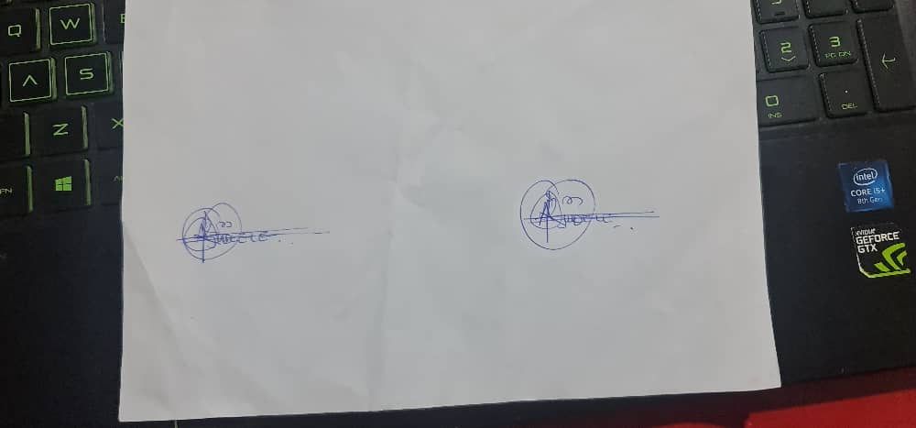
________________________ _______________________
SIGNATURE OF SUPERVISOR SIGNATURE OF STUDENT

DESIGN AND IMPLEMENTATION OF AN AUTOMATIC LEVEL RIG USING
HYDROSTATIC PRESSURE INTERFACED WITH INTERNET OF THINGS

BY

ORUKELE AJOKPAOGHENE SCOTT
AAU/SPS/FET/ELE/M.Eng./17/43609

DEPARTMENT OF ELECTRICAL AND ELECTRONICS ENGINEERING,
FACULTY OF ENGINEERING AND TECHNOLOGY,
AMBROSE ALLI UNIVERSITY,
EKPOMA, NIGERIA.

DECEMBER, 2023

DESIGN AND IMPLEMENTATION OF AN AUTOMATIC LEVEL RIG USING
HYDROSTATIC PRESSURE INTERFACED WITH INTERNET OF THINGS

BY

ORUKELE AJOKPAOGHENE SCOTT
AAU/SPS/FET/ELE/M.Eng./17/43609

DEPARTMENT OF ELECTRICAL AND ELECTRONICS ENGINEERING,
FACULTY OF ENGINEERING AND TECHNOLOGY,
AMBROSE ALLI UNIVERSITY,
EKPOMA, NIGERIA.

DECEMBER, 2023

CERTIFICATION

This is to certify that this study was carried out by ORUKELE AJOKPAOGHENE SCOTT
with Matriculation number AAU/SPS/FET/ELE/M.Eng./17/43609 , in the Department of
Electrical and Electronics Engineering, Faculty of Engineering and Technology, School of
Postgraduate Studies, Ambrose Alli University, Ekpoma.

……………………………..… ………………………
Engr. Dr. Okundamiya, M. S. Date
Supervisor
Department of Electrical and Electronics Engineering,
Faculty of Engineering and Technology,
Ambrose Alli University,
Ekpoma, Nigeria.

……………………………..… …………………..
Engr. Benedict Omatahunde Date
Head of Department
Department of Electrical and Electronics Engineering,
Faculty of Engineering and Technology,
Ambrose Alli University,
Ekpoma, Nigeria.

....................................... .............………
External Examiner Date

DEDICATION

I dedicate this project work to our heavenly father for His infinite mercy and divine grace throughout this programme.

ACKNOWLEDGEMENT

I wish to express my profound gratitude and appreciation to God for His unfailing love and care in sustaining my life, to Him be all the glory, honour and adoration forever and ever. I sincerely thank my supervisor, Engr. Dr. M. S. Okundamiya, for his immerse contribution during this programme. I also thank Engr. Dr. O. Omorogiuwa for his concern, support and encouragement during the programme. Similarly, Engr. Prof. A.M. Obiazi was also of great support. God bless you Sir.
Very warm appreciation goes to all staff of the Department of Electrical and Electronics Engineering for their support in one way or the other to the successful completion of this programme.
I also acknowledge my immediate family, parents and siblings for their moral support throughout the programme. My friends and classmates are not left out. I appreciate you all.

TABLE OF CONTENTS
Title Page ii
Certification iii
Dedication iv
Acknowlegdement v
Abstract vi
Table of Contents vii
List of Figures x
List of Tables xi

ABSTRACT

Level measurement data is very important in some liquid-related
fields. An automatic level control system is needed to prevent the
difficulties when one does the controlling manually. This system uses
PIC16F877A micro controller to control the system, hydrostatic
pressure sensor to measure the level, and IOT for real time monitoring
via internet. This approach will help utilities operators improve low
cost liquid management systems, specially by using rising technologies
and IoT is one of them. The Internet of Things (IoT) could prove to be
one of the most important methods for developing more utility-proper
systems.

TABLE OF CONTENTS
Chapter One
1.0.0 Introduction 12
1.0.1 Internet of Things (IOT) 12
1.0.2 Methodology 14
1.0.3 Importance of Level Measurement 14
1.0.4 Applications And Advantages of IOT Based Liquid Level Monitoring
14
1.0.5 Block Of Microcontroler Based Level Control Using Hydrostatic
Pressure Rig Interfaced With IOT 15
1.0.5.1 Description of Block Diagram 15
Chapter Two
2.0.0 Literature Review 17
2.0.1 What is Meant By Hydrostatics? 17
2.0.2 Hydrostatic Devices 19
2.0.2.1 Displacers, Bubblers and Differential Pressure Transmitters..... 19
2.0.3 Related Work 23
2.0.4 Component Review 26
2.0.4.1 Transformer 26
2.0.4.2 Rectifier 27
2.0.4.3 Filter Circuit 29
2.0.4.4 Voltage Regulator 31
2.0.4.5 Resistor 31
2.0.4.5a Resistor Colour Code 32
2.0.4.5b Pull-Up And Pull-Down Resistor 33
2.0.4.6 Capacitors 33
2.0.4.7 Switches (Push Button Switch) 34
2.0.5 Microcontroller 36
2.0.5.1 PIC16f877a Microcontroller Pin Outs 37
2.0.6 Diode 40
2.0.6.1 Uses of Diodes 40
2.0.7 Liquid Crystal Display (LCD) 40
2.0.8 Pumps 42
Chapter Three
Design Methodology 43
3.0.0 Design 43
3.0.1. Design Specification 43
3.0.2 Design Details 44
3.0.2.1 Power Supply Unit 44
3.0.2.2 The Level Sensor Unit 47
3.0.2.3 The Display Unit 50
3.0.2.4 The Pump and Pump/FCE Control Unit 52
3.0.2.5 The Controller Unit 54
3.0.2.6 The Alarm Unit 56
3.0.2.7 Selection Of the GSM/GPRS Module Unit . 57
3.0.2.8 Communication Data Format Between the Controller and the IOT
Application 59
3.0.3 IOT Appllication 60
3.0.3.1 Software Design 60
3.0.3.2 Algorithm Generation 60
3.0.3.3 Coding 61
3.0.3.4 Flowchart 62
3.0.3.5 Circuit Diagram 62

3.0.3.4 Principle Of Operation 63
Chapter Four
4.0.0 Construction 65
4.0.1 Construction of the Hardware Unit 65
4.0.1.1 Construction Procedures 65
4.0.1.1 Construction Details 66
4.0.1.2 Construction of The Circuit And Installation 66
4.0.1.3 Construction of The Casing 68
4.0.2 Software Development 69
4.0.3 Testing and Result 71
4.0.4 Cost Analysis 72
Chapter Five
5.0.0 Appraisal 74
5.0.1 Conclusion 74
5.0.2 Recommendation 75
References
Appendix

LIST OF FIGURES.
Fig. 1.0: Block diagram of level control using hydrostatic pressure rig
interfaced with IOT. 15
Fig 2.1: Displacers, Bubblers and Differential Pressure Transmitters 20
Fig. 2.2: Shows a bubbler-type sensor. 21
Fig 2.3: Depicts a differential pressure level sensor. 22
Fig 2.4: Circuit Symbol of a Transformer 26
Fig 2.5: Bridge Rectifier Circuit Diagram 28
Fig. 2.5a: Positive Half Cycle Circuit Diagram 28
Fig. 2.5b: Negative Half Cycle Circuit Diagram 29
Fig. 2.6: Full-wave Rectifier with Smoothing Capacitor 30
Fig. 2.7: Diagram of Resistor with Colour bands 33
Fig. 2.8: (a) Pull-Up Resistor (b) Pull-Down Resistor 33
Fig.2.9: Symbols of Capacitor 34
Fig. 2.19: Structure of a diode 40
Fig. 2.20 Show the conventional directions of currents. 40
Fig. 2.21: Liquid Crystal Display 41
Fig. 2.22: 16x2 LCD Display 41
Fig. 3.1: Power Supply Unit 44
Fig. 3.2: The pressure transmitter and the microcontroller interface. 50
Fig. 3.3: Display Unit Interface with the Controller unit 52
Fig. 3.4: FCE Control Unit 53
Fig. 3.5: The Controller Unit 56
Fig. 3.5: The Controller Unit 56
Fig.3.6: The Alarm-Buzzer Unit Circuit 57
Fig.3.7: The GSM/GPRS Module Unit 59
Fig.3.7: The Flow Chart. 62
Fig 4.1: Piping and instrumentation diagram of the project work. 67
Fig 4.2a: Pictorial diagram of the project showing the front view. 68
Fig 4.2b: Pictorial diagram of the project showing the side view. 68

LIST OF TABLES
TABLE 2.1: Resistor Colour Coding ` 32
TABLE 2.2: Configuration of Switches 35
TABLE 2.1: Table showing pin description of the microcontroller. 37
TABLE 4.1: Test and Result 71
TABLE 4.2: Project Cost Estimate

CHAPTER ONE
  - INTRODUCTION
Level measurement has seen considerable change over the past decades – from purely mechanical level measurement through to complex electronic sensors using various measuring principles. The large number of different technologies for measuring level (such as hydrostatic, reed chain, magneto resistivity, radar, ultrasound, optical and many more) today offers the user the possibility to choose the most suitable sensor technology for his individual application. In continuous level measurement, hydrostatic pressure (also known as hydrostatic level measurement) is the principal sensor technology and measuring principle, with a market share of approximately 40 % by sales volume. Still considerably ahead of ultrasound and radar technologies, hydrostatic sensors for level measurement are installed in more than every second measuring point. Thus, the immense importance of this technology is reflected in its steady growth from US$ 650 M in the pre-crisis year of 2008, to around US$ 770 M in 2013.
The typical process plant contains many tanks, vessels, and reservoirs. The main function of these containers is to store or process materials. Accurate measurement of the contents of these containers is very vital. Usually the material in the tanks is liquid whose level must be accurately measured. It is with this and more convenience that this project was developed.

1.0.1 INTERNET OF THINGS (IOT)
Today the Internet has become ubiquitous, has touched almost every corner of the globe, and is affecting human life in unimaginable ways. However, the journey is far from over. We are now entering an era of even more pervasive connectivity where a very wide variety of appliances will be connected to the web. We are entering an era of the “Internet of Things” (abbreviated as IoT). This term has been defined by different authors in many different ways. Let us look at two of the most popular definitions. Vermesan et al define the “Internet of Things is simply an interaction between the physical and digital worlds”. The digital world interacts with the physical world using a plethora of sensors and actuators. Another definition by Peña-López et al defines the Internet of Things as a paradigm in which computing and networking capabilities are embedded in any kind of conceivable object. We use these capabilities to query the state of the object and to change its state if possible. In common parlance, the Internet of Things refers to a new kind of world where almost all the devices and appliances that we use are connected to a network. We can use them collaboratively to achieve complex tasks that require a high degree of intelligence.
For this intelligence and interconnection, IoT devices are equipped with embedded sensors, actuators, processors, and transceivers. IoT is not a single technology; rather it is an agglomeration of various technologies that work together in tandem.
The storage and processing of data can be done on the edge of the network itself or in a remote server. If any preprocessing of data is possible, then it is typically done at either the sensor or some other proximate device. The processed data is then typically sent to a remote server. The storage and processing capabilities of an IoT object are also restricted by the resources available, which are often very constrained due to limitations of size, energy, power, and computational capability. As a result, the main research challenge is to ensure that we get the right kind of data at the desired level of accuracy. Along with the challenges of data collection, and handling, there are challenges in communication as well. The communication between IoT devices is mainly wireless because they are generally installed at geographically dispersed locations. The wireless channels often have high rates of distortion and are unreliable. In this scenario reliably communicating data without too many retransmissions is an important problem and thus communication technologies are integral to the study of IoT devices.

1.0.2 METHODOLOGY
In the quest to a successful level measurement, level control using hydrostatic pressure rig interfaced with IOT was fully taken into consideration. The project work was commenced by studying other various projects done in relation to this very project and then improve on them. Such as making the process inoperable when there is difficulty in transmitting the parameter to and fro the IOT application possible due to communication challenges. (see on iot graghics, set the status to off).

1.0.3 IMPORTANCE OF LEVEL MEASUREMENT
Level measurement is important in the industry as it gives information about the quality of inputs and the finished product available. It enables manufacturers to know the amount of quantity of various inputs, chemical, liquid, solid and so on available for production and therefore to determine how long they will operate before the next supply is due. In the petroleum and petrochemical industries, level measurement is important in sales of crude and finished products.
Also, level measurement is essential in Water Company since it allows for automatic control and packaging quantity of water. When liquid is to be sold, its volume is measured in quantity and a price tag is attached accordingly.

1.0.4 APPLICATIONS AND ADVANTAGES OF IOT BASED LIQUID LEVEL MONITORING
1. Continuous monitoring of any liquid – Water stored in a container OR a lake or pond, Chemical – stored in big containers in Industries.
2. These monitoring can be either to calculate the usage or to keep a check on leakage as well as theft detection.
3. Since, the project uses IOT; the liquid level monitoring can be done from any remote place.
4. User has a history of records, since these records are stored on a website database.

Disadvantages:
- Dependent on the relative density of the material
- More expensive than simpler types
- Expensive for high accuracy applications

1.0.5 BLOCK OF MICROCONTROLER BASED LEVEL CONTROL USING HYDROSTATIC PRESSURE RIG INTERFACED WITH IOT

Fig. 1.0 Block diagram of level control using hydrostatic pressure rig interfaced with IOT.

1.0.5.1 DESCRIPTION OF BLOCK DIAGRAM
- THE PUMP UNIT: This unit represents the 220V AC Water Pump that lifts the process (water) from the storage tank into the process reservoir.
- LEVEL SENSOR: The level sensor is hydrostatic level sensor, it is a submersible pressure transmitter that has a pressure diaphragm where the inner side of the diaphragm is vented to atmospheric pressure through a vent tube in the cable and the outer side is in contact with the liquid and measuring the static pressure of the liquid column above the transmitter. This static pressure is basically caused by the weight of the fluid on top of the transmitter and is used to calculate the level of the liquid.
- Microcontroller: The microcontroller (PIC16F877A) takes the digital signals from the output of the analogue to digital converter (ADC), processes it and displays the value on the display circuit.
- The internet of things, or IoT, is a system of interrelated computing devices, mechanical and digital machines, objects, animals or people that are provided with unique identifiers ( UIDs ) and the ability to transfer data over a network without requiring human-to-human or human-to-computer interaction.
- Display: The display used for this design is the liquid crystal display (LCD). It displays whatever has been processed by the micro controller and the display shows when the processes are above or below the set point on the liquid crystal display (LCD).
- Power supply unit: The power supply unit provides the needed voltage for the circuit to operate. Power supply is basically made up of the transformer, rectification circuit, smoothing circuit and a voltage regulation circuit.

CHAPTER TWO

2.0.0 LITERATURE REVIEW

2.0.1 WHAT IS MEANT BY HYDROSTATICS?
Hydrostatic pressure sensors are used for the measurement of level or filling height of a liquid. Hydrostatic pressure measurement is suited for level measurement due to the hydrostatic effect of non-flowing fluids. This physical principle describes the effect of the weight force of a stationary, meaning non-flowing, liquid on a measuring point. This weight force is usually described as “hydrostatic pressure”.
The most important condition for hydrostatic level measurement is what is called the “hydrostatic paradox.” This means that, regardless of the shape and volume of a vessel, the hydrostatic pressure at the measuring point of a tank or vessel is proportional only to the filling height. Thus, despite the apparent contradiction of an over-proportional increase or decrease in the volume or weight of a liquid with change in height, the hydrostatic pressure at the measuring point is solely proportional to the absolute filling height, and not to the filling quantity.
Level measurement in open, vented vessels:
In hydrostatic level measurement in open or vented basins or vessels, a continuous pressure compensation of the ambient air with the gas phase above the liquid takes place. Thus, the ambient pressure that acts on the medium as an additional “force” always resembles the ambient pressure acting on the whole system, including the level sensor. If one therefore uses a pressure sensor with a relative pressure measuring cell, a pressure sensor that is compensated or vented (just like the tank) to the ambient pressure, it “automatically” compensates for the effect of this ambient pressure on the level measurement. This means that a relative pressure sensor in vented vessels and tanks completely “cancels out” the atmospheric pressure overlying on the liquid from the level measurement. Thus, the hydrostatic pressure corresponds only to the filling height of the liquid (Fig. 2). Therefore, the filling height of an open tank or vessel is calculated using the following equation:
h = p / (ρ * g)
p = hydrostatic pressure [bar (relative)]
ρ = density of the liquid [kg/m³]
g = gravitational force or grav. acceleration [m/s²]
h = height of the liquid column [m]
As a simple rule of thumb for water as a medium, one can assume that a pressure of 1 bar (relative) corresponds to a filling height of 10 m. Rule of thumb (media of density ~ 1,000 kg/m³ ): h= 1 bar (relative) / (1,000 kg/m³ * ~ 10 m/s²) = 10 m
The rule of thumb demonstrates that the hydrostatic pressure in a vessel is proportional to the filling height of the medium, as long as it maintains a constant density, completely independent from shape/fill quantity.

Level measurement in sealed, gas-tight vessels:
The level measurement in sealed, gas-tight vessels, which is frequently found in the chemical industry, requires a compensation of the pressure of the enclosed gas phase above the liquid. The enclosed pressure of the gas phase acts as an additional force on the liquid and distorts any hydrostatic pressure measurement at the base of the vessel. Thus, this distorting influence must be compensated through an additional pressure measurement of the gas phase. Frequently, a second pressure sensor is used for the measurement of the gas pressure. This application effectively represents a differential pressure measurement, where the two-separate pressure measurements are offset against each other. This offset calculation can be made either by two individual sensors or via an integrated differential pressure sensor. In this application, the sensors used can either be relative (sensor with ambient pressure compensation) or absolute pressure variants (sensor with sealed vacuum reference).
Thus, the filling height of a sealed tank or vessel is calculated using the following equation:
h = (p₂ - p₁) / (ρ * g)
p₂ = hydrostatic pressure [bar]
p₁ = pressure of the enclosed gas in the vessel [bar]
ρ = density of the fluid [kg/m³]
g = gravitational force or grav. acceleration [m/s²]
h = height of the liquid column [m]

2.0.2 HYDROSTATIC DEVICES

2.0.2.1 Displacers, Bubblers and Differential Pressure Transmitters.
Bubblers, differential pressure transmitters and displacers are all different hydrostatic measurement devices. Changes in temperature cause a change in a liquid's the specific gravity of the liquid; similarly changes in pressure also affect the specific gravity of the vapor that is present over the liquid. As a result of these changes, the accuracy of the measurement is reduced.
Displacers are based on the Archimedes principle. Figure 2 shows a column of solid material placed in a vessel.
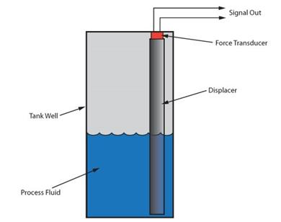

Fig 2.1: Displacers, Bubblers and Differential Pressure Transmitters
Displacement level gauges operate on Archimedes’ principle. The force needed to support a column of material (displacer) decreases by the weight of the process fluid displaced. A force transducer measures the support force and reports it as analog signal.
The density of the displacer is always more than that of the process fluid, so that it extends from the lowest level of the tank to the highest level that needs to be measured. The column displaces a volume of the fluid due to a rise in the process fluid; the displaced volume is equal to the product of cross-sectional area of the column and the level of process fluid in the displacer.
A buoyant force, whose magnitude is equal to the product of the displaced volume and the process fluid density, exerts an upward thrust on the displacer, which brings down the force required to support it against the gravitational force. This change is monitored by the transducer linked to the transmitter, and translates the change in force to level.
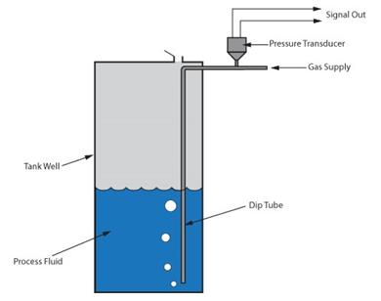

Fig. 2.2: Shows a bubbler-type sensor.
Bubblers sense process fluid depth by measuring the hydrostatic pressure near the bottom of the storage vessel.
The bubbler method is used in vessels that work under atmospheric pressure. A purge gas is carried in a dip tube with its open end near the opening of the vessel into the tank. The purge gas is usually air, but in some cases where there is danger of an oxidative reaction with the process fluid or contamination, dry nitrogen is used.
Due to the flow of gas through the dip tube outlet, the tube pressure rises till it is more than the hydrostatic pressure generated by the liquid level at the outlet. The product of the process fluid density and its depth from the end of the dip tube to the surface is equal to the pressure, which is monitored by a pressure transducer connected to the tube.
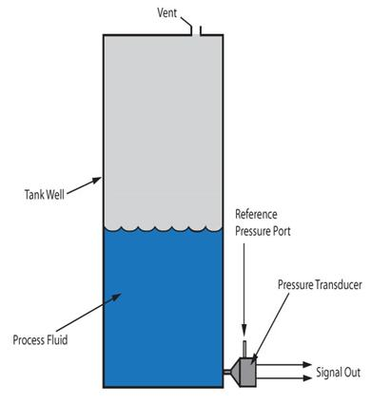

Fig 2.3: Depicts a differential pressure level sensor.
Differential pressure sensors monitor for the process fluid level by measuring the total pressure difference between the fluid at the bottom of the tank and the vessel pressure.
In this sensor, the difference between the total pressure at the bottom of the tank and the head or static pressure in the vessel is indicative of the level. Similar to the bubbler method, the product of the fluid density and the height of the fluid in the vessel gives the hydrostatic pressure difference. Atmospheric pressure is considered as reference. In order to maintain headspace at atmospheric pressure a vent is provided at the top.
Unlike bubblers, DP sensors can be used in vessels by simply connecting the reference port to a port in the vessel, which is above the maximum fill level. The need for liquid purges or bubblers depends on the physical conditions of the process and/or the location of the transmitter with respect to process connections.

2.0.3 RELATED WORK
2.0.3.1 Design of Low Cost Multi Channel Data Acquisition System for Meteorological Application BY: Nisha Kashyap, Department of Electronics and Communication Engineering National Institute of Technology, Rourkela, Odisha May 2015.
The primary objective of the present work is to design a low cost multi-channel data acquisition system which can be used for meteorological application. The proposed multi-channel data acquisition system acquires ambient temperature, barometric pressure, altitude, humidity and light intensity data from environment and stores the data for future use. The sensors are connected with a low-cost microcontroller (ATmega328) unit which performs the data acquisition and data logging operation. A real time clock is used to keep current time with the measurement. Different communication interfaces such as serial communication, wireless communication and Ethernet communication are used in the data acquisition system. In serial communication, the sensor data are logged in COM port of PC. LabVIEW based application is developed which provides graphical user interface for the user. VISA protocol is used to communicate the COM port data with LabVIEW. Other communication protocol such as wireless communication and Ethernet communication protocol is used to transmit the sensor data over a communication channel. The data is uploaded in Ethernet which can be viewed using a web browser. In wireless communication Xbee transmitter and Xbee receiver modules are used to transmit data over a longer distance. The salient features of this developed system is that the system is low cost, uses open source software’s like Arduino and python and the system is economical (that is - INR 6500). This developed system performs satisfactorily under different condition. The system is tested for 24 hour in April 2015 and provides satisfactory results.

2.0.3.2 Bluetooth Based Data Acquisition System BY: Suresh Gurjar, Department of Electrical Engineering National Institute of Technology Rourkela Rourkela 769008 INDIA. May 2015
Data acquisition systems are devices used to collect information to document or analyse some physical phenomenon such as voltage, force or temperature. Data acquisition systems available in the market are very expensive, bulky and power hungry. However, PC based data acquisition system offers a lot of benefit in terms of processing speed, display resolution and connectivity capabilities. The Project aims at designing and implementing a portable, economical and power efficient real-time data acquisition system. The proposed system comprises of a hardware circuitry and a Graphical User Interface (GUI) based on MATLAB environment. The hardware device consists of an 8-bit microcontroller interfaced with a serial ADC chip and a Bluetooth serial module. The Bluetooth HC-05 module is used to provide a wireless connectivity between the hardware and the PC. For testing purpose, the sampling rate of ADC is set to 833 Hz, capturing 50 values per 0.06 second. Whereas on the PC side, the GUI receives the sampled values transmitted by the hardware device and plots the real-time signal waveform. It has been found that the GUI plots the signal waveform with good quality and efficiency. The proposed system can be deployed in number of industrial applications such as remote device controlling and ECG data acquisition with some adjustments in the hardware. The wireless connectivity reduces the complexity of cables and probability of occurrences of the accidents in industrial areas.
2.0.3.3 Real-Time Measurement And Monitoring System Using Zigbee And Labview By: Muhammad Hairul Bin Yahaya, Faculty of Electronic and Computer Engineering Universiti Teknikal Malaysia Melaka JUNE 2015.
Wireless communication technologies become popular in real-time industrial environments. This project describes the fundamental work of real time measurement and monitoring system with Arduino, ZigBee, and Graphical Programming language (LabVIEW). Thickness of the item is taken as a parameter that will convert into the number of items. By acquiring the analogue data from the ultrasonic sensor, the suitable signal conditional is fed to Arduino. It is connected to the ZigBee transmitter module, which transmits the data to the ZigBee receiver. As a result, the data received will be viewed on a PC via LabVIEW. The methodology describe in the proposed work is useful for designing Wireless Sensor Network (WSN) system in the industrial application such as real levelling storage. The experimental of transmission range and observation of data required in LabVIEW was reported. The combination of measurement, wireless transmission and monitoring system can be improved of accuracy of measurement, especially for sustainability of better working place.
2.0.3.4 Design and Development of Microcontroller Based Liquid Level Detector with Graphical Output. BY: N.T. Makanjuola; O.O. Shoewu; L.A. Akinyemi; and A.A. Ajasa, Lagos State University, Epe Campus, Epe, Lagos, Nigeria
This paper presents and discusses the design and construction of a microcontroller-based liquid level detector with graphical output. This was achieved using a programmable microcontroller and some additional components, including a pumping machine. This project was done with the use of a 220V AC power supply which was stepped down to 12V AC via a transformer. A switch was added as a protective device to break the power supply in case of a bridge or short circuit. A voltage regulator was incorporated to convert the incoming AC voltage to DC voltage, as 5V DC is needed by the microcontroller to execute its work. The microcontroller responds to the program written through the MAX 232. The PC at the last stage of the design shows the status of the indicator probes at various levels of water. The PC also shows the levels of water in percentage (10%, 15%, 25%, 50%, 75% and 100%) when the pumping machine began to transport water from the first probe to the last probe. The system is applicable in industry and for residential use to avoid spillage of liquid (hazardous or otherwise) to the environment.

2.0.4 COMPONENT REVIEW
The components used in this project are briefly explained below:

2.0.4.1 TRANSFORMER
A transformer is a static device that is used to transfer electric power from one circuit to another at the same frequency with minimal power loss. Its physical basis is mutual induction between two circuits linked by a common magnetic flux. They work only with AC (Alternating current) because they require changing magnetic field to be created in the core. Transformer can either be step-up or step-down transformer that is raises or lowers the voltage in a circuit respectively with a corresponding increase or decrease in current. They have higher efficiency as loss of power is generally small.

Secondary
Winding
Primary
Winding

Fig 2.4: Circuit Symbol of a Transformer

OPERATION OF A TRANSFORMER
When an alternating current flow through the primary coil, the resulting magnetic flux in the core induces an alternating voltage across the secondary coil. If the secondary coil is connected to a load, it caused induced current to flow. The iron core is often limited to prevent eddy current loss by heat generation.

$$Efficiency=\frac{Power Output}{Power Input} × \frac{100}{1}$$

This can be best described when the transfer is on no-load and when is on-load mode.

2.0.4.2 RECTIFIER
Rectifier is a device which converts the sinusoidal AC voltage into either positive or negative pulsating DC. P-N junction diode, which conducts when forward biased and practically does not conduct when reverse biased, can be used for rectification that is for conversion of ac into dc. The rectifier typically needs one, two or four diodes. Rectifiers may be either half-wave rectifier or full-wave rectifier (Centre-tap or bridge) type.
FULL WAVE BRIDGE RECTIFIER
This type of single-phase rectifier uses four individual rectifying diodes connected in a closed loop “bridge” configuration to produce the desired output. The main advantage of this bridge circuit is that it does not require a special centre tapped transformer, thereby reducing its size and cost. The single secondary winding is connected to one side of the diode bridge network and the load to the other side as shown below.

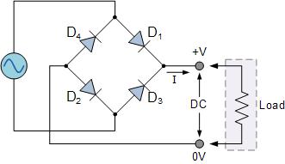

Fig 2.5: Bridge Rectifier Circuit Diagram
a. The Positive Half Cycle
The four diodes labelled D₁ to D₄ are arranged in “series pairs” with only two diodes conducting current during each half cycle. During the positive half cycle of the supply, diodes D1 and D2 conduct in series while diodes D3 and D4 are reverse biased and the current flows through the load as shown below.
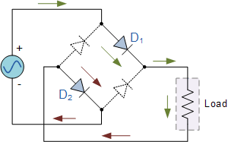

Fig. 2.5a: Positive Half Cycle Circuit Diagram
b. Negative Half Cycle
During the negative half cycle of the supply, diodes D3 and D4 conduct in series, but diodes D1 and D2 switch “OFF” as they are now reverse biased. The current flowing through the load is the same direction as before.
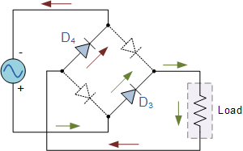

Fig. 2.5b: Negative Half Cycle Circuit Diagram
As the current flowing through the load is unidirectional, so the voltage developed across the load is also unidirectional the same as for the previous two diode full-wave rectifier, therefore the average DC voltage across the load is 0.637V_{max.} The output voltage from a rectifier circuit has a pulsating character that is, it contains unwanted ac components (components of supply frequency f and its harmonics) along with dc component. For most supply purposes, constant direct voltage is required than that furnished by a rectifier. To reduce ac components from the rectifier output voltage a filter circuit is required.

2.0.4.3 FILTER CIRCUIT
The filter circuit makes use of the smoothing capacitor to remove the ac component of rectifier output but allows the dc component to reach the load. We can therefore increase its average DC output level even higher by connecting a suitable smoothing capacitor across the output of the bridge circuit as shown below.
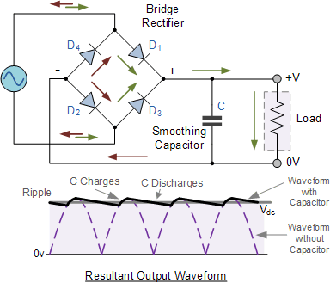

Fig. 2.6: Full-wave Rectifier with Smoothing Capacitor
The smoothing capacitor converts the full-wave rippled output of the rectifier into a smooth DC output voltage. Generally, for DC power supply circuits the smoothing capacitor is an Aluminium Electrolytic type that has a capacitance value of 100uF or more with repeated DC voltage pulses from the rectifier charging up the capacitor to peak voltage.
However, there are two important parameters to consider when choosing a suitable smoothing capacitor and these are its Working Voltage - which must be higher than the no-load output value of the rectifier and its Capacitance Value - which determines the amount of ripple that will appear superimposed on top of the DC voltage.
Thus, filter is a device which passes dc component to the load and blocks current ac components of the rectifier output. Filter is typically constructed from reactive circuit current elements such as capacitors and/or inductors and resistors. The magnitude of output dc voltage may vary with the variation of either the input ac voltage or the magnitude of load current. So, at the output of a rectifier filter combination a voltage regulator is required, to provide an almost constant dc voltage at the output of the regulator. The voltage regulator may be constructed from a Zener diode, and/or discrete transistors, and/or integrated circuits (ICs). Its main function is to maintain a constant dc output voltage. However, it also rejects any ac ripple voltage that is not removed by the filter. The regulator may also include protective devices such as short-circuit protection, current limiting, thermal shutdown, or over-voltage protection.

2.0.4.4 VOLTAGE REGULATOR
A voltage regulator generates a fixed output voltage of a pre-set magnitude that remains constant regardless of changes to its input voltage or load conditions. There are two types of voltage regulators: linear and switching.
A linear regulator employs an active (BJT or MOSFET) pass device (series or shunt) controlled by a high gain differential amplifier. It compares the output voltage with a precise reference voltage and adjusts the pass device to maintain a constant output voltage.
A switching regulator converts the dc input voltage to a switched voltage applied to a power MOSFET or BJT switch. The filtered power switch output voltage is fed back to a circuit that controls the power switch on and off times so that the output voltage remains constant regardless of input voltage or load current changes.

2.0.4.5 RESISTOR
A resistor is a device that offers opposition to the flow of an electric current in a circuit. The potential drop across a resistor is proportional to the current flowing through it, the constant being the resistance of the resistor.
Mathematically given that:
I = Current flowing in amperes (A)
V = Potential difference in volts (V)
R = Resistance (constant proportionality)
Since V α I …………………… (i)
Introducing the proportionality constant, the above equation now becomes;
V = IR …………………………… (ii)
Where R is the proportionality constant, which is also the resistance offered by the resistor.
Therefore,
The unit of resistance is ohms (Ω).
A conductor is said to have a resistance of 1 ohm when it allows a current of one ampere (1A) to flow through it when voltage of 1V is applied across its terminal.

2.0.4.5a RESISTOR COLOUR CODE

TABLE 2.1: Resistor Colour Coding
Digit | Colour | Multiplier | Tolerance
 | Silver | 10⁻² | 10%
 | Gold | 10⁻¹ | 5%
0 | Black | 10º | -
1 | Brown | 10¹ | 1%
2 | Red | 10² | 2%
3. | Orange | 10³ | 3%
4. | Yellow | 10⁴ | 4%
5. | Green | 10⁵ | -
6. | Blue | 10⁶ | -
7. | Violet | 10⁷ | -
8. | Grey | 10⁸ | -
9. | White | 10⁹ | -

1st Digit
2nd Digit
Multiplier
Tolerance

Fig. 2.7: Diagram of Resistor with Colour bands

2.0.4.5b PULL-UP AND PULL-DOWN RESISTOR
In digit circuit there is need to maintain their input at fixed potential either high or low to prevent them from floating thereby producing in determinate output. A pull-up resistor is connected between the floating input and Vcc, while the pull-down resistor is connected between the floating input and ground. The value of resistance depends on the voltage of the supply and it varies from some few kΩ to hundred to kΩs.

Digital Circuit

Digital Circuit

Fig. 2.8: (a) Pull-Up Resistor (b) Pull-Down Resistor

2.0.4.6 CAPACITORS
A capacitor consists basically of two conductor plates separated by a dielectric or vacuum so as to store electrical energy by electrostatic stress in the dielectric. A capacitor is said to have capacitance because of its ability to store changes. the S.I unit of the capacitance of a capacitor is farads. But farads are rather larger unit so it is usual to use the microfarad (μF or 10⁻⁶F), Nano farad (nf or 10⁻⁹) and the Pico farad (pf or 10⁻¹²F).
A capacitor has a capacitance of one farad (If) when it receives a charge of one coulomb (1C) at a potential of one volt (1V).

Fig.2.9: Symbols of Capacitor

2.0.4.6a CONNECTIONS OF CAPACITORS
Similar to resistor, capacitors in circuit may be connected together in two ways:
1. Series: In series, the same current flows through all the components but a different potential difference (voltage) can exist across each one.
2. Parallel: In parallel, the same potential difference (voltage) exists across all the components but each component may carry a different current.

2.0.4.7 SWITCHES (PUSH BUTTON SWITCH)
In electronics, a switch is an electrical component that can break an electrical circuit by interrupting the current or diverting it from one conducting to another or it creates (or makes) a path for the current to flow through a circuit.
A switch has two conductive pieces often metal, called contacts that touch a complete (make) a circuit and separate to open (break) the circuit.

Fig. 2.10: Symbol of a switch
There are various types of switch, for example: toggle switch, rocker switch, mercury tilt switch, knife switch, push button and foot switch. The foot switch which is used in this project is basically a push button.
In a push button switch, the content remains in one place unless actuated. The contacts can either be normally open (ON) until closed by the switch action.
A switch with both types of contact is called a changeover switch. These may be ‘make-before-break’ which momentarily connects both circuits or may be ‘break-before make’ which interrupts one circuit before closing the other.
The term poles and throw are also used to describe switch contact variations. The number of poles is the number of separate circuits which are controlled in a switch. For example, a 2-pole switch has two separate identical sets of contact controlled by the same knob. The number of throws is the number of separate positions that the switch can adopt. The various configurations of throws and poles are itemized in the table below.

TABLE 2.2: Configuration of Switches
Configuration | Abbreviation | Description | Symbol
Single pole single throw | SPST | A simple ON-OFF switch with two terminals either connected or disconnected
Single pole-double throw/single pole center OFF | SPDT/SPCO | A simple change over switch; COM (common) is connected to L₁ or L₂ and to center position (for SPCO) to isolate both L₁ and L₂.  L₂ | L₁  com
Double pole single throw | DPST | Equivalent to two SPSI switches controlled by a single mechanisms.
Double pole double throw | DPDT | Equivalent two SPDT switches controlled by a single mechanism

2.0.5 MICROCONTROLLER
A microcontroller (MCU) is a computer-on-a-chip used to control electronic devices. It is a type of microprocessor emphasizing self-sufficiency and cost-effectiveness, in contrast to a general-purpose-microprocessor (the kind used in a PC). A typical microcontroller contains all the memory and interfaces needed for a simple application, whereas a general-purpose microprocessor requires additional chips to provide these functions.
A microcontroller is a single integrated circuit with the following key features:
- processor unit – ranging from small and simple 8-bit processors to sophisticated 32- or 64- bit processors
- input / output interfaces such as
- peripherals such as timers
- RAM for data storage
- ROM, EEPROM or Flash Memory for program storage
- Clock generator – often an oscillator for a quarter timing crystal, resonator or RC circuit.
The integration drastically reduces the number of chips and the amount of wiring and printed circuit Board (PCB) space that would be needed to produce equivalent systems using separate chips. The microcontroller used in this project is the PIC16F877A.

2.0.5.1 PIC16F877A MICROCONTROLLER PIN OUTS
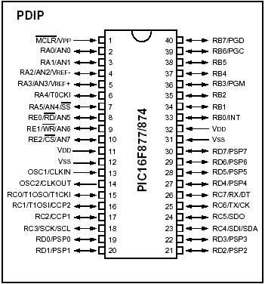
Figure 2.16 PIC Microcontroller Pin Configuration

2.0.5.2 PIN DESCRIPTION INPUT/OUTPUT PORTS
PIC16F877 has 5 basic input/output ports. They are usually denoted by PORT A (R A), PORT B (RB), PORT C (RC), PORT D (RD), and PORT E (RE). These ports are used for input/ output interfacing. In this controller, “PORT A” is only 6 bits wide (RA-0 to RA-7), ”PORT B” , “PORT C”,”PORT D” are only 8 bits wide (RB-0 to RB-7,RC-0 to RC-7,RD-0 to RD-7), ”PORT E” has only 3 bit wide (RE-0 to RE-7).

TABLE 2.1: Table showing pin description of the microcontroller.
PORT-A | RA-0 to RA-5 | 6 bit wide
PORT-B | RB-0 to RB-7 | 8 bit wide
PORT-C | RC-0 to RC-7 | 8 bit wide
PORT-D | RD-0 to RD-7 | 8 bit wide
PORT-E | RE-0 to RE-2 | 3 bit wid
All these ports are bi-directional. The direction of the port is controlled by using TRIS(X) registers (TRIS A used to set the direction of PORT-A, TRIS B used to set the direction for PORT-B, etc.). Setting a TRIS(X) bit ‘1’ will set the corresponding PORT(X) bit as input. Clearing a TRIS(X) bit ‘0’ will set the corresponding PORT(X) bit as output.
(If we want to set PORT A as an input, just set TRIS(A) bit to logical ‘1’ and want to set PORT B as an output, just set the PORT B bits to logical ‘0’.)
o Analog input port (AN0 TO AN7) : these ports are used for interfacing analog inputs.
o TX and RX: These are the USART transmission and reception ports.
o SCK: these pins are used for giving synchronous serial clock input.
o SCL: these pins act as an output for both SPI and I2C modes.
o DT: these are synchronous data terminals.
o CK: synchronous clock input.
o SD0: SPI data output (SPI Mode).
o SD1: SPI Data input (SPI mode).
o SDA: data input/output in I2C Mode.
o CCP1 and CCP2: these are capture/compare/PWM modules.
o OSC1: oscillator input/external clock.
o OSC2: oscillator output/clock out.
o MCLR: master clear pin (Active low reset).
o Vpp: programming voltage input.
o THV: High voltage test mode controlling.
o Vref (+/-): reference voltage.
o SS: Slave select for the synchronous serial port.
o T0CK1: clock input to TIMER 0.
o T1OSO: Timer 1 oscillator output.
o T1OS1: Timer 1 oscillator input.
o T1CK1: clock input to Timer 1.
o PGD: Serial programming data.
o PGC: serial programming clock.
o PGM: Low Voltage Programming input.
o INT: external interrupt.
o RD: Read control for parallel slave port.
o CS: Select control for parallel slave.
o PSP0 to PSP7: Parallel slave port.
o VDD: positive supply for logic and input pins.
o VSS: Ground reference for logic and input/output pins.

2.0.6 DIODE
It is a two terminal device that consists of a P-N junction formed either in Ge or Si crystal. Its symbol in the figure below:
P
N

Fig. 2.19: Structure of a diode

The P and N type regions are referred to as anode and cathode respectively. The diagram below indicates the conventional flow when forward biased, it is the same direction in which hole flows take place.

Fig. 2.20 Show the conventional directions of currents.

A P-N junctions diode is one way device offering low resistance when forward-biases. Hence, such diodes are mostly used as rectifiers i.e. for converting AC to DC.

2.0.6.1 USES OF DIODES
i. For rectification
ii. Light emitting diode is used for indicator
iii. For protection of relay to prevent base e.m.f

2.0.7 LIQUID CRYSTAL DISPLAY (LCD)
A liquid-crystal display (LCD) is a flat-panel display or other electronic visual display that uses the light-modulating properties of liquid crystals. Liquid crystals do not emit light directly LIQUID.

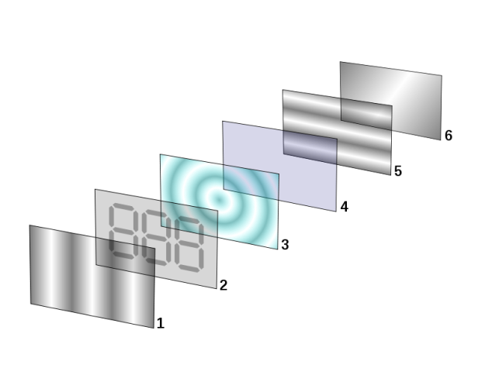

Fig. 2.21: Liquid Crystal Display
Reflective nematic twisted liquid crystal display. LCDs are available to display arbitrary images (as in a general-purpose computer display) or fixed images with low information content, which can be displayed or hidden, such as pre-set words, digits, and 7-segment displays as in a digital clock. They use the same basic technology, except that arbitrary images are made up of a large number of small pixels, while other displays have larger elements.

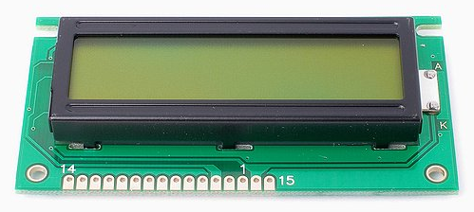

Fig. 2.22: 16x2 LCD Display

LCDs are used in a wide range of applications including computer monitors, televisions, instrument panels, aircraft cockpit displays, and signage. They are common in consumer devices such as DVD players, gaming devices, clocks, watches, calculators, and telephones, and have replaced cathode ray tube (CRT) displays in nearly all applications. They are available in a wider range of screen sizes than CRT and plasma displays, and since they do not use phosphors, they do not suffer image burn-in. LCDs are, however, susceptible to image persistence.

2.0.8 PUMPS
A pump is a machine that adds pressure and energy to a fluid to make it flow
Pump makes an integral part of a process/control plant. In most cases in the processes flow trend, it is noted that without the use of pump, some flow regime would have been impossible.
Pumps perform essentially the following three functions:
1. To move fluids from lower levels to higher levels
By installing pumps in a pipe work system, it can enable fluid to flow from a lower to a higher level.
2. To move fluid from lower pressure areas to higher pressure areas.
3. To increase the flow rate (volume) of the fluid. The capacity of a pump is the amount (volume) of fluid that can be moved in a given time. it is often measured in liters per minute (L/min) or gallons per minute (Gal/min). In the oil industry, it is usually measured in barrels per hour or barrels per day (bpd).
Gauges are used to record the pressure at the pump suction and discharge points. A pump adds pressure to a fluid as it passes through it. The discharge pressure is actually the suction pressure, plus the pressure the pump adds.

CHAPTER THREE

DESIGN METHODOLOGY

3.0.0 DESIGN
This chapter contains the design analysis, calculations, component selection and design specification.
The design was divided into the following units for simplicity and efficiency. Below are the following units of the project:
- The Power supply unit
- The Level Sensor unit
- The Controller Unit
- The Display unit
- The Alarm Unit
- The GSM/GPRS Unit
- The FCE/PUMP control unit

3.0.1. DESIGN SPECIFICATION
This System has the following Design Specifications:
Input Voltage: 220/230V AC @ 50Hz.
Level Sensor Type: Hydrostatic pressure Sensor
Level Measurement Range: 0CM to 100CM
Display: Supports Visual Presentation of the Level 16x2 liquid crystal display (LCD).
Pump Type: ½ HP (500watts), Centrifugal Water Pump.
Process Type: WATER.
Controller Type: PIC16F877A Microcontroller from Microchip Corporation.

3.0.2 DESIGN DETAILS

3.0.2.1 POWER SUPPLY UNIT
This unit converts the 220V AC to 5V DC required by the circuit. It was implemented with the following components:
• 220V/12V step down transformer
• Bridge Diode
• Capacitor
• Voltage regulator
Below is the circuit diagram of the power supply unit:

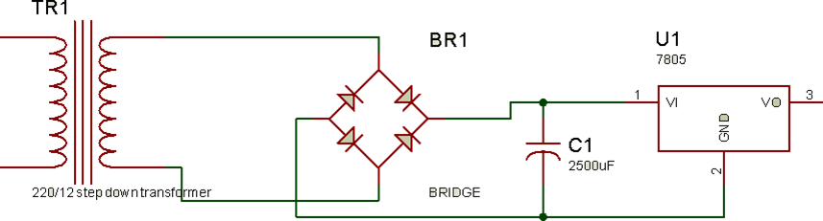

Fig. 3.1: Power Supply Unit
Voltage Regulator:
As we require a 5V we need LM7805 Voltage Regulator IC.
7805 IC Rating:
• Input voltage range 7V- 35V
• Current rating IC = 1A
• Output voltage range V_{max}=5.2v, V_{min}=4.8v

Transformer:
Selecting a suitable transformer is of great importance. The current rating and the secondary voltage of the transformer is a crucial factor.
• The current rating of the transformer depends upon the current required for the load to be driven.
• The input voltage to the 7805 IC should be at least 2V greater than the required 2V output, therefore it requires an input voltage at least close to 7V.
• So, we chose a 12V transformer with current rating 500mA (Since 12*√2 = 16.97V).
Rectifying circuit:
The bridge rectifier converts the ac voltage input to dc voltage at its output. The diodes IN4007 was used. The best is using a full wave rectifier due to the following good qualities:
• Its DC saturation is less, as in, both cycle diodes conduct.
• Higher Transformer Utilization Factor (TUF).
• 1N4007 diodes are used as it is capable of withstanding a higher reverse voltage of 1000v whereas 1N4001 is 50V.
• Center Tap Full Wave Rectifier.
The choice of the bridge rectifier depends on:
i. Peak inverse voltage.
ii. The forward current rating
The diode forward current rating is the maximum that the diode can conduct before failing. The diode should be selected in such a way that the current passing through it should be less than the forward current rating. The peak inverse output is the reverse voltage that the diode has to block when not conducting.
Peak Inverse Voltage (PIV) = $\sqrt{2 } ×Vrms$
where V_{rms} = transformer output = 12Vac
- Peak inverse voltage = $\sqrt{2 }$ x 12 = 16.97v
- The diodes used has forward current ≥ 500mA and PIV ≥ 16.97V
Selection of the Filter Capacitor (C1):
The filter capacitor smoothens the dc voltage from the bridge rectifier.
The choice depends on:
i. The capacitor breakdown voltage
ii. The ripple percentage required
Capacitor breakdown voltage (V_{c}) is gotten by taking KVL from the bridge rectifier output to capacitor terminal. Using Fig. 3.1
V_{peak} – V_{d} – V_{c} = O
Where V_{peak} = bridge rectifier output
V_{d} = drop across bridge rectifier diodes
V_{c} = capacitor terminal voltage
16.97v – 1.4v – V_{c} = 0 ------------- (3.1)
For full wave rectification, on each half section, 0.7 is drop across each of the two conducting diodes. Which gives 1.4v (2 x 0.7v)
equation (3.1) becomes
15.57 – V_{c} = 0
where V_{c} = 15.57V
In practices, the rule is to use a capacitor with breakdown voltage double of the terminal voltage:
V1_{c} = 2 x Vc
V1_{c} = 2 x 15.57
= 31.14V
A standard value of 35V was used.
Capacitor Capacitance:
$C=I load÷2fV∆$ for full wave
Where VΔ is the difference between the maximum peak voltage and the minimum peak voltage.
Maximum peak = 15.57v
Minimum peak = 15.57 - % ripple
% ripple = 15.57 – minimum peak
taking minimum peak = 13.57v
% ripple = (15.57 – 13.57) v = 2v
A standard value of 2500uf capacitor was used.

3.0.2.2 THE LEVEL SENSOR UNIT
This unit measures the Process (WATER) level in the Reservoir. It senses the hydrostatic pressure and outputs a signal that is proportional to the pressure been measured.

Requirements of the Level Sensor
- It should be able to measure the process level within a reasonable range.
- It should be easy to use and requires less biasing components.
- The power requirements should be reasonable.
- It should be cost effective and readily available.
- Its output signal should be easily interfaced with a controller.

Selection of the Level Sensor.
The 2-wire pressure transmitter from Rosemount Corporation was selected. Below are some of its features:
- Supply voltage range from 12V to 30V_{DC}
- Pressure range is 1 to 300PSIG
- 4mA to 20mA output signal on two wire.
- Biased with a 250 ohms resistor to convert the voltage to 4mA to 20mA.
- Portable in size for easy installation.
The pressure transmitter is strategically fitted at the bottom of the fabricated rectangular reservoir that contains the process to be controlled for this design. The output terminals of the pressure transmitter are connected to one of the Analog to digital converter input pin of the microcontroller. Below is the interface calculation between the pressure transmitter unit and the microcontroller.
The voltage signal from the pressure transmitter is directly proportional to the pressure measured.
For example:
Voltage signal from transmitter = 2.5V
Transmitter Range = 300psig
Therefore, with direct proportionality, the Pressure measured is: 150psig.
Converting the Pressure to Level using Hydrostatic Method:
Recall; $P= ρgh$ .
Where P = Pressure; $ρ$ = Density; h = Level/Height; g = acceleration due to gravity.
h = P/$ρ$g;
P = 150psig;$ρ$= 1000g/m⁻²; g = 9.81ms⁻²

Fig. 3.2: The pressure transmitter and the microcontroller interface.

3.0.2.3 THE DISPLAY UNIT
This unit gives a Visual Presentation of the Water Level (in centimeter) inside the Reservoir.
Requirements for the Display Unit
- Should be large enough to give a clear visual presentation of the Water level.
- Be Large Enough to represent the Level of the process in the reservoir.
- Should be easy to use or programmed.
- Should have an easy connection interface that is fewer biasing components.
- Should be available and Cost effective.

Selection of the Display Unit
16x2 (16 characters per Row, 2 Rows) liquid crystal display was selected. Below are the choice of the selection:
- It gives a clear visual presentation of data.
- It can to represent the Level of the Process in the Reservoir.
- It has an easy connection interface.
- It is cheap.
- It is available.
The display unit gets its data from the controller Unit. It is connected to The PORTD PINS of the PIC16F877A Microcontroller. Below is the circuit interface of the Display unit.

Fig. 3.3: Display Unit Interface with the Controller unit

3.0.2.4 THE PUMP AND PUMP/FCE CONTROL UNIT
The pump control element was implemented with a 220V_{AC} 1/2hp Water pump. The FCE Control unit is switching circuits that assist the Controller unit to switch the Pump ON and OFF. Below are the requirements of the unit.
Requirement of the Switching circuit:
- It should not be a complex switch circuit.
- It should be able to Power the Pump.
- It should be easily controlled by the controller unit i.e. easy connection interface.
- The components involved should be available and cost effective.

Selection of the Switching Circuit
The transistor switching circuit was selected. It was implemented with the Following Components:
- 12V, 30A Relay
- BC547 NPN Transistor
- Biasing Resistor

The transistor switching circuit was selected because it met the above requirements. This Unit is directly controlled by the Microcontroller through PIN 15. Below is the Circuit diagram of the entire FCE control Unit.

Fig. 3.4: FCE Control Unit

Selection of the Switching Transistor
The choice of the switching transistor is based on:
1. The supply voltage
2. The maximum collector current.
To determine the collector current, Collector current = relay coil current.
$$Relay Coil Current=\frac{Relay coil voltage}{Relay coil resistance}$$
= $\frac{12V}{275 Ω}$ = 0.04A = 40mA
The general-purpose transistor BC547 was used.
The BC 547 has the following specifications:
Gain (ß) = 120
V_{BE} = 0.7V
I_{C}(max) = 60mA
Selection of the Relay
The choice of the relay is based on:
1. Supply voltage
2 Relay contact current
3. The Watts requirement of the Pumps
Pump used has the following specification:
Input voltage: 220v AC.
Watts: 500 watts (1/2 Hp).
Using a Relay of 12V 30A DC (JQX12)
Supply voltage in the circuit = 12V.
Power Of the relay: P=IV = 30A x 220V = 6600watts = 6.6KW
Therefore, the relay power is greater than the Pump Power requirements i.e. 6.6KW > 500Watts.

3.0.2.5 THE CONTROLLER UNIT
This Unit is the Heart of the Entire System. It performs the entire logic of the system. Below is the requirements of the controller unit.
Requirements of the Controller
- Should be able to interface the display unit.
- Should have ADC Module required to interface the pressure transmitter.
- Should have UART Module required to interface the GSM/GPRS Module
- Should be stable and efficient.
- Should have enough Input/output Pins to accommodate the entire system.
- Should be easily programmed.
- It should available and cost effective.
Selection of the Controller
The PIC16F877A Microcontroller from Microchip Corporation was selected. Below are the reasons of the selection.
- It is a 40pin Microcontroller, it has enough input/output pins.
- A pin in the microcontroller can supply 5V 20mA.
- It has internal ADC Module Required to interface the Pressure transmitter
- It Has UART Serial communication Module Required by the GSM/GPRS Module.
- It has an easy programming interface.
- It is stable, cost effective and available.
The PIC16F877A Microcontroller was biased with a 16Mhz Crystal and two (2) 15pf Capacitors.
To determine the time the microcontroller executes one instruction:
One machine cycle is the time taken to execute an instruction.
Machine cycle = 4 pulses of crystal oscillator.
Hence, $Time taken=\frac{Oscillator Frequency}{4}$
For one machine cycle: $Time taken=\frac{16MHz}{4}$ = 4MHz
1/F= 1/4MHZ = 1μs
The controller executes one instruction in 1 micro seconds.

Fig. 3.5: The Controller Unit

3.0.2.6 THE ALARM UNIT
This Unit Gives Audible Sound For when the process level reaches the SET Point. Below is the requirement of the ALARM unit.
Requirements of the ALARM Unit
- Should be able to give a good audible alert.
- Should have feasible connection interface.
- Reasonable power requirements i.e. input voltage and current demand.
- Should be cost effective and readily available.

Selection of the ALARM.
The unit was implemented with a DC Buzzer Alarm. Below is the choice of the selection of the buzzer alarm:
- It has a wide operating voltage i.e. 5-24V
- It gives a clear and audible sound.
- It is easily biased with a resistor.
- It is cheap and very available.
The Unit is Directly Controlled by the Controller Unit. It is connected to Pin 19 of the PIC16F877A Microcontroller. It was biased a 1K Resistor. Below is the circuit diagram of the Buzzer Unit:

Fig.3.6: The Alarm-Buzzer Unit Circuit
Buzzer Operating Current
The buzzer operates with a voltage of 5-25V;
Current: 2mA to 10mA;
A pin of the microcontroller can supply 5V (as specified in Pic16f877a microcontroller datasheet)
Supply 5mA at 5V to the Buzzer:
From Ohms law: V=IR;
R=V/I
V=5V; I=5mA
R = 5/(5x10⁻³) = 1000;
Therefore R=1K ohms.

3.0.2.7 SELECTION OF THE GSM/GPRS MODULE UNIT
This unit enables the microcontroller to send and receive data over the IOT Network.
After research, this unit was implemented with SIM800L Module from SIMCOMM Group. Below are some of its features:
- It uses RS232 serial communication protocol that is TX, RX and common terminal.
- It uses GSM/GPRS AT command sets. Easy protocol for the microcontroller
- It operates with 5V DC at 100m A
- It requires no biasing components and available and cost effective
The SIM800L is a cheap and portable GSM breakout board with all the capabilities of the larger SIM900 shields. Here are the features of the SIM800L breakout board:

- 2G quad-band @ 850/900/1800/1900 MHz
- Receive and make calls using the speaker and microphone outputs
- Receive and send SMS
- Connect to the Internet via GPRS
- Listen to FM radio broadcasts
- Accepts AT Commands
The Unit directly interfaced with the microcontroller. Below are the AT Command sets used between the microcontroller and the SIM800L Module to transmit over the IOT.
AT + RST
AT + CIPMODE=1
AT + CIPSTART=” TCP”,” mathworks.net”,80
AT + CIPSEND
GET /iot/data.php?level&time&date HTTP/1.1
Host: mathworks.net
See appendix A for complete source code. Below is the circuit interface between the microcontroller and the GSM/GPRS Module unit.

Fig.3.7: The GSM/GPRS Module Unit

3.0.2.8 COMMUNICATION DATA FORMAT BETWEEN THE CONTROLLER AND THE IOT APPLICATION
The Controller transmit a 24bit (3 byte) DATA packet to the IOT Application at every 30 seconds. Each byte in the packet represent the Level value of a process. The IOT Application receives the 3-byte packet data, parse it and displays it on the Process image in the Application.
The IOT Application transmit a 1-byte CONTROL Packet to the microcontroller, where the byte represents the control state of the FCE of the process. The byte can either be 00H or FFH i.e. OFF FCE or ON FCE respectively.
The communication baud rate between the controller and the IOT Application through the GPRS/GSM module is 9600bps.

3.0.3 IOT APPLLICATION
This is a graphical user interface unit of the system. It was designed with Microsoft visual studio 10 using C# Programming language. The Design carries one reservoir image, the reservoir image represents the Level of the process.
The IOT Application also has TWO TEXTBOX AND BUTTON under the reservoir image, it is used to input the LEVEL SET POINTS of the Process. See the Pictorial View of the IOT Application and source code at APPENDIX.

3.0.3.1 SOFTWARE DESIGN
The software design is divided into three stages. These are algorithm generation, flow chat representation and coding.

3.0.3.2 ALGORITHM GENERATION
An algorithm is a statement of the procedure adopted in solving a problem. The sequence of the system operation is stated below:
- Initialize the system on start.
- Initialize the display unit.
- Get Signal from pressure transmitter and convert to Level.
- Update the Display Unit depending on the value read.
- Update the Pump control unit.
- Transmit level value to IOT application using the GSM/GPRS Module.
- Wait for control Packet from IOT Application
- Update Pump Control Unit based on Control packet Received.
- End process.

3.0.3.3 CODING
The coding is done in C language. The code contains the instruction of program to direct the affairs of the entire design. There are six subroutines in the complete code. Each subroutine performs specific function as group of instructions. The subroutine and functions are stated as follows.
1. Initialization: This subroutine initializes the microcontroller including preloading the counters and reference values for the system.
2. Read Signal: This subroutine makes the controller to get the voltage signal from the ADC.
3. Conversion: This subroutine converts the value read from ADC to the equivalent level.
4. Update Display: The subroutine enables the controller to display value on the LCD display.
5. Update Control: This subroutine enables the microcontroller to control the switching circuit
6. IOT: This subroutine enables the controller to transmit and receive data over the IOT Network to the Application.

3.0.3.4 FLOWCHART

Fig.3.7: The Flow Chart.

3.0.3.5 CIRCUIT DIAGRAM

3.0.3.4 PRINCIPLE OF OPERATION
On power up, the power supply unit provides 5V DC for the microcontroller, LCD, SIM800L and 12VDC for the pressure transmitter module. The microcontroller then initializes its internal registers and also the LCD Display.
It then read the Voltage signal from the ADC pin connected to the pressure transmitter, converts the signal to the equivalent level, display the value on the LCD and transmits the value to the IOT application through the GSM/GPRS Module.
When the application receives the data packet, it updates it on the Reservoir GUI image, it then compares the received value with the SET Points, and sends to the Microcontroller a control packet that is proportional to the based on the output of the comparison. The microcontroller upon receiving the control packet, updates the FCE Control unit based on the received control packet. The entire process is repeated again.

CHAPTER FOUR

4.0.0 CONSTRUCTION
This chapter contains construction details. The construction consists of three main steps namely:
- The construction of the hardware
- Software development
- Installation

4.0.1 CONSTRUCTION OF THE HARDWARE UNIT
The hardware unit consists of the electric circuit. In the construction of the electronic circuit, the following tools or materials were used:
- Digital Multimeter
- Soldering Iron
- Head Sucker
- Side Cutter
- Sand Paper
- Circuit Probes
- Soldering Lead

4.0.1.1 CONSTRUCTION PROCEDURES
We have the following procedure adopted in the construction of the electronic unit.
i. Pre-connection and Testing: The components were first connected on a project board to test their functionality and to effect any change if need be.
ii. Component layout and placement: The actual connection was done on a new vero board. First, the new board connection surface was cleaned by robbing lightly with the sand paper, there after the positions of the components were marked out on its surface. The essence of this is to maximize the Vero board space.
iii. Inter Connection: The various components were interconnected according to the wiring diagram. The connections were made using components, lead and connecting wires.
iv. Joining Operation: The resulting joints were made permanent (soldered) using hot soldering iron and soldering lead.
v. Clean-up Operation: Excess soldering lead and soldering lead between Vero board tracks were removed using the lead sucker.

4.0.1.1 CONSTRUCTION DETAILS
The construction of this project is divided into the following groups:
- Construction of the Circuit.
- Construction of the Casing.

4.0.1.2 CONSTRUCTION OF THE CIRCUIT AND INSTALLATION
The circuit was constructed with the following components: PIC16f877a microcontroller, 16x2LCD display (3), 220v/12v step- down transformer, 7805 voltage regulator, resistors, LED, 12v/30A DC relay, connecting belt, Off-and-On switch and so on. These components were properly soldered on a PCB according to the above circuit diagram. Care was taken to avoid mistakes and errors.
After the construction, the whole circuit was fitted with bolt and nut inside a white rectangular plastic Casing (15cmx10cmx10cm). Below is a pictorial view of the project construction:

Fig 4.1: Piping and instrumentation diagram (P&ID) of the project work.

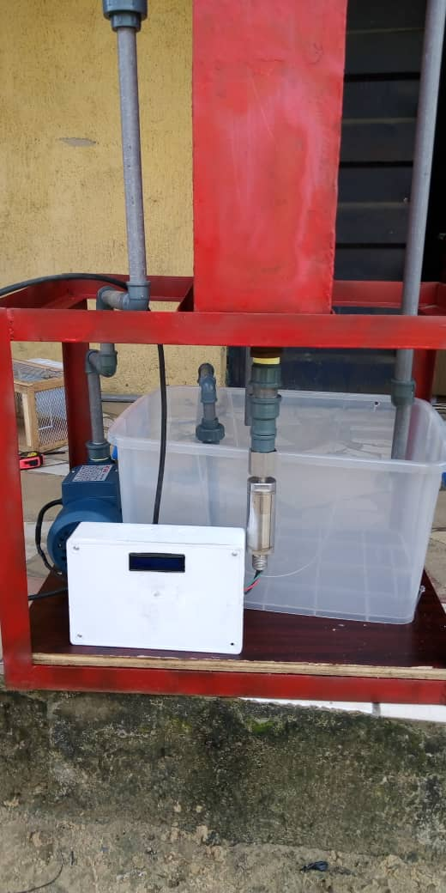
Fig 4.2a: Pictorial diagram of the project showing the front view.
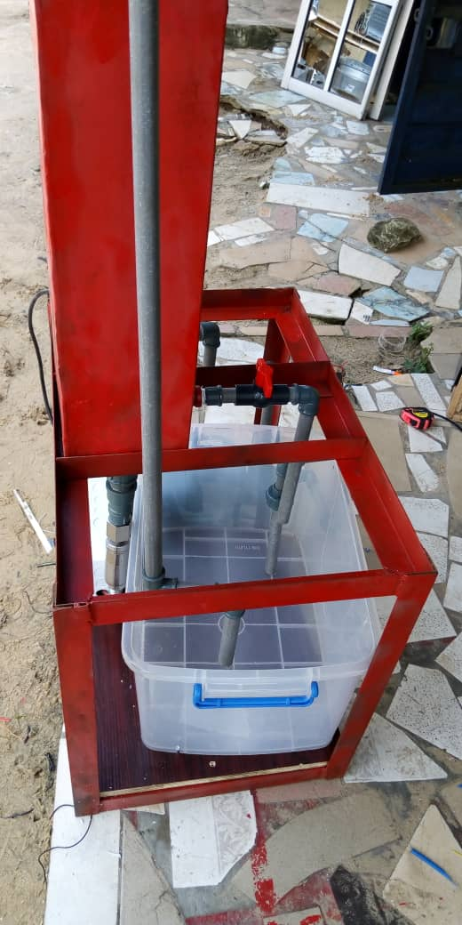
Fig 4.2b: Pictorial diagram of the project showing the side view.
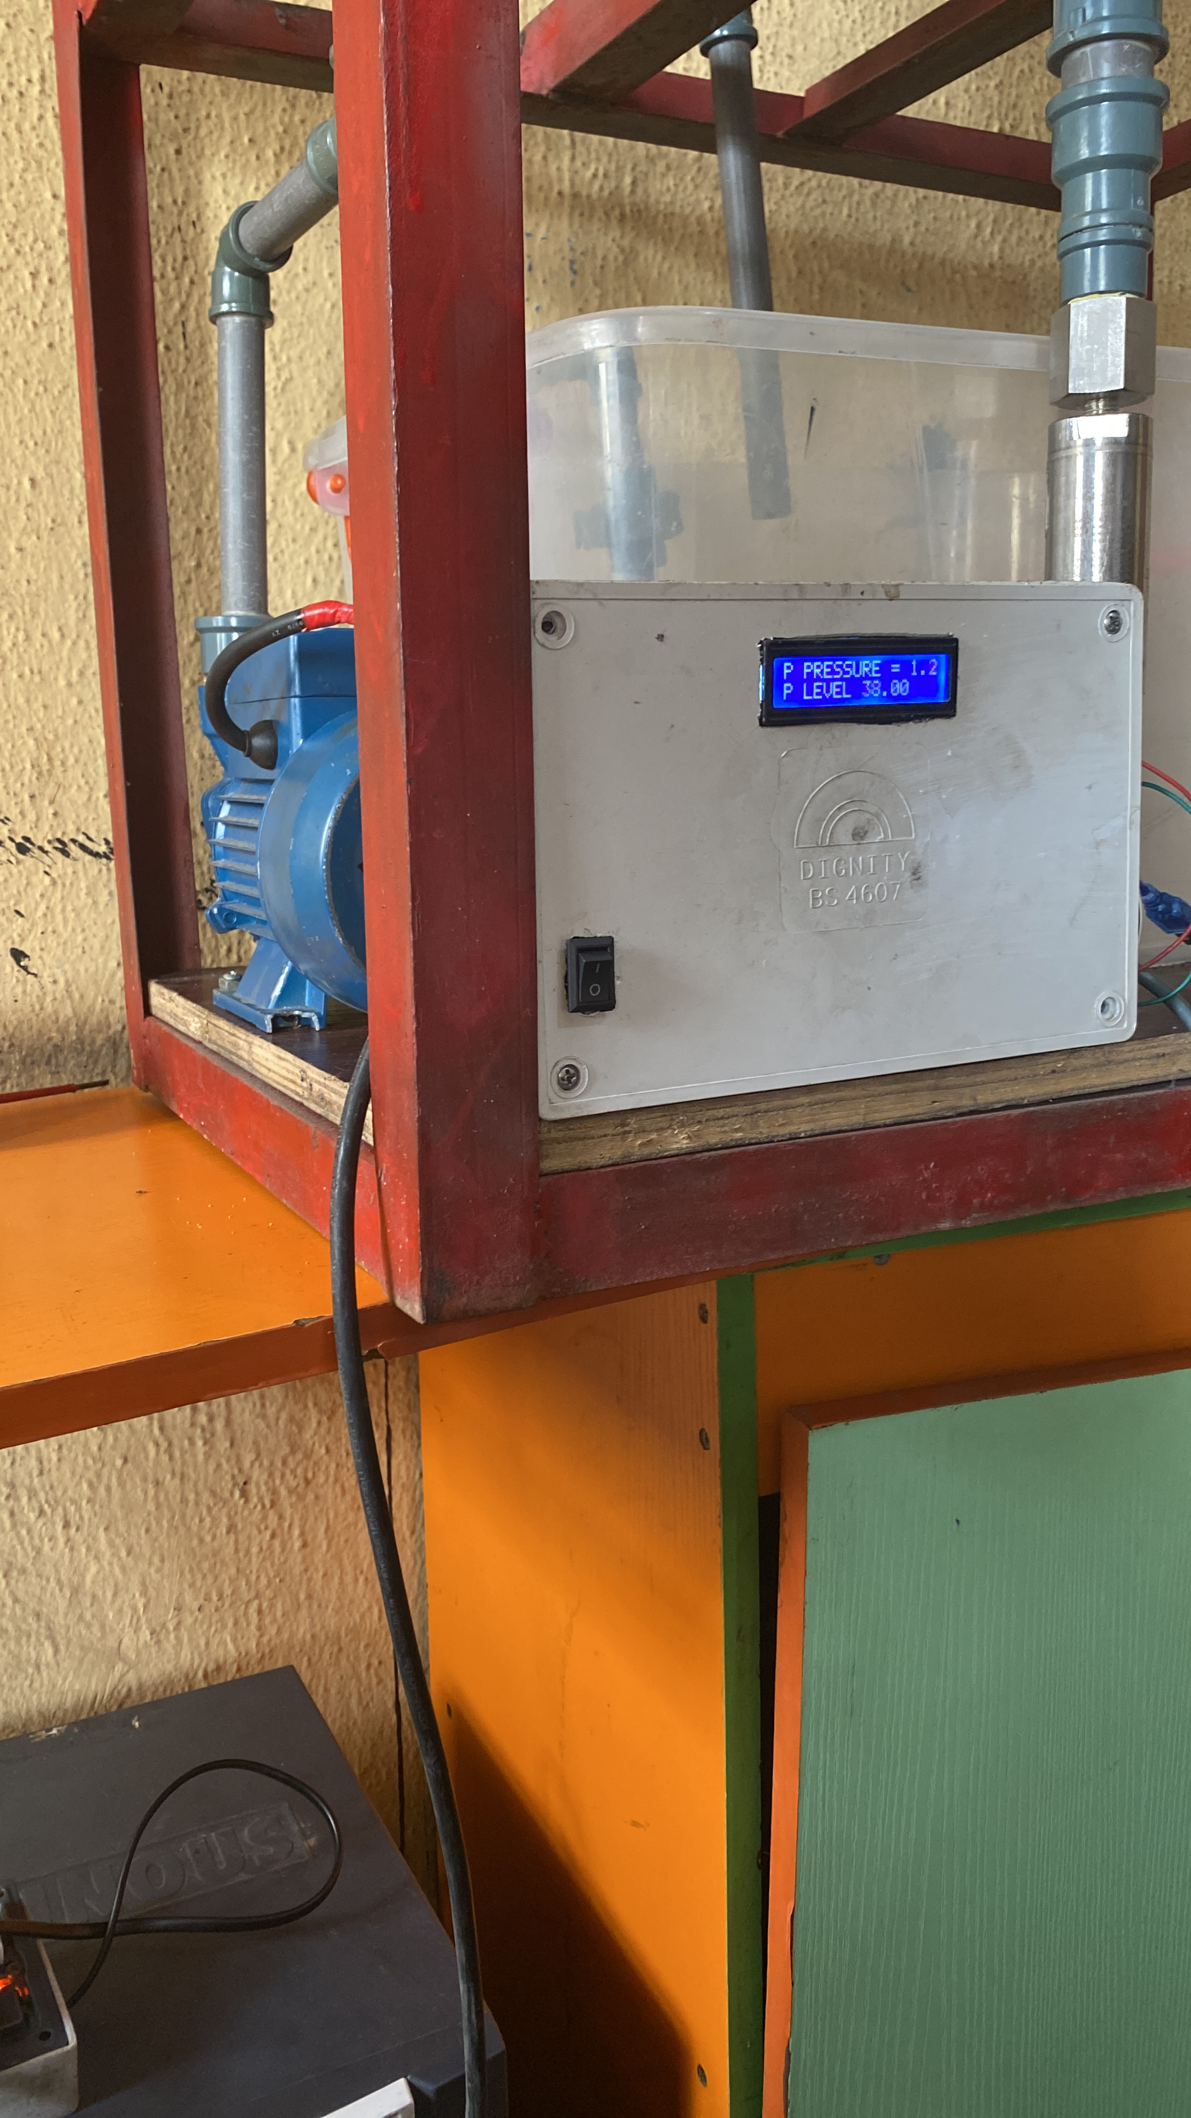

Fig 4.2b: Pictorial diagram of the project showing the system running

4.0.1.3 CONSTRUCTION OF THE CASING
The Casing is made up of ½ horse-power water pump, two cylindrical containers, rectangular box, water pipes, valve and so on. For the two Cylinder containers, one serves as the Process Tank while the other is the Reservoir. The suction line of the pump was connected to the bottom of the Process Tank, while the discharge line is connected to the top of the reservoir cylinder.

4.0.2 SOFTWARE DEVELOPMENT
Since it is an embedded system, software part must be added to give a complete system. The software development passed through the following stages.
i. Coding
ii. Creating text files.
- Compiling
- Simulating
- Debugging
- Burning

i. Coding: The program codes to determine the operation of the system was generated. These were written down on paper using the instruction set corresponding to microcontroller use. All signals were adhered to, so as to prevent obvious errors.
ii. Creating Text File: The text files were created by using note pad editor; the codes on paper through the note pad work space were typed into the computer system and saved with an “ASM” extension.
iii. Compiling: This is done to convert the text file to HEX file. The V edsim 51 IDE was used. The program code on the editor was assembled. HEX file was generated alongside a list file and error report file. The error report file contains errors, especially syntax errors, the list-file is an editable file that shows errors in the code which prevents successful compilation.
iv. Simulating: The program HEX file, referred to as the object code was then simulated. All commands are within the development environment. The movement of data and process within the microcontroller can be easily seen. Also, output and input devices are available to mimic the actual, physical construction.
v. Debugging: Illegal operations were corrected by way of debugging the source codes until the required operations were obtained. The steps taken in debugging are as follows:
a. The list file was opened so as to locate any errors that may be present in the program.
b. Each program line with errors is displayed in the list file.
c. Corrections were made in the main programs with reference to the lines with errors in the list file.
d. The program was recompiled again after necessary corrections have been made.
e. In absence of any other error, the list file indicated it.
vi. Burning: This is the process of loading the HEX file into the microcontroller. The writing of the hex file into the chip was done using a programmer. The Hex file basically consists of assembly code level. The programmer converts this to machine code understood by the microcontroller.
The programmer (Wellon 2008) was connected to the PC’s USB port.
To load the hex file, the following steps were taken:
- The programmer was connected to the computer through the USB port using the USB-to-USB cord. Chip is inserted into the programmer socket.
- The software program controlling the programmer was launched with command.
- The microcontroller chip to be programmed was selected via software, erased, checked for blankness before loading Hex file into the chip.
- The hex file is located and loaded into the chip via the programmer sockets. The programmer writes the hex code to the chip.
- After writing was done, the system notified the programmer and the chip was removed from USB programmer device socket and plugged to the Vero-board on-board socket.

4.0.3 TESTING AND RESULT
The tests and results obtained were given in the table below.

TABLE 4.1: Test and Result
Test | Aim | Equipment used | Result | Conclusion
Short circuit test | To detect short circuit on the electronic circuit | Digital Multimeter set to test continuity | All the test points R>1Ω | No short circuit present in the circuit connection
Open circuit test | To detect open circuit on the electronic circuit | Digital Multimeter set to test continuity | All the tested points read R>1Ω | No open circuit was present in the circuit connection
Sensor Response Test | To check if the output pulse is produced when object is sensed | Digital Multimeter set to mA. | The milliammeter equivalent readings were noted on the DMM as the level changes. | Analog signal was present.
Operation test | To ascertain the functionality of the system | The system was powered and observed | Operated as required | System in good condition

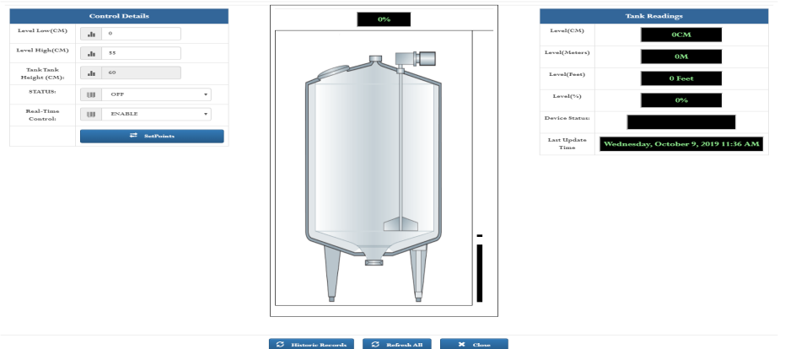

Fig. 4.3: IOT Graphics display of water level in the tank.
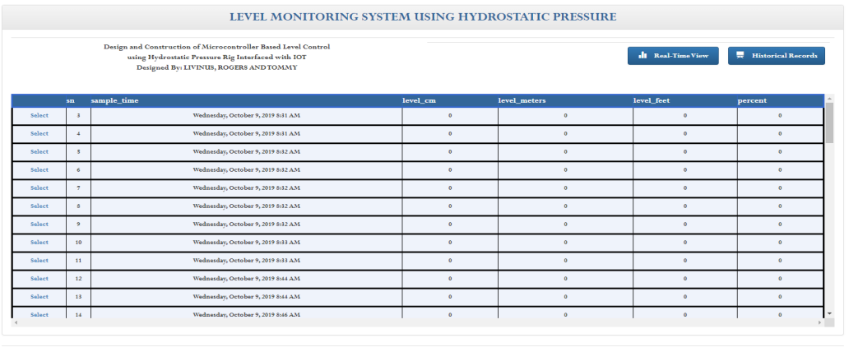 Fig. 4.4: IOT historical records of parameters received.

4.0.4 COST ANALYSIS

TABLE 4.2: Project Cost Estimate
S/N | Description of item | Qty | Unit Price (₦) | Total (₦)
1 | 220/24V Transformer | 1 | 1500 | 1500
2 | Rectifier diodes IN5403 | 4 | 150 | 1000
3 | 10k resistor | 10 | 20 | 200
4 | 25V,1000 micro Farad capacitor | 2 | 100 | 200
5 | 5KΩ variable Resistor | 1 | 200 | 200
6 | PIC16f877A | 1 | 4000 | 4000
7 | 2 wire Pressure Transmitter sensor | 1 | 33000 | 33000
8 | LM7805 | 2 | 100 | 200
9 | SIM800L GSM Module | 1 | 15000 | 15000
10 | LED | 10 | 30 | 300
11 | Plastic Casing | 1 | 2500 | 2500
12 | OFF/ON switch | 1 | 150 | 150
13 | 16x4 LCD display | 1 | 3500 | 3500
14 | PUMP | 1 | 12000 | 12000
15 | 1k Resistors | 14 | 10 | 140
16 | Connecting belt Wires | 3 | 150 | 450
17 | Connecting wires (CAT 6) | 3 | 150 | 450
18 | 40 pin IC socket | 1 | 30 | 30
19 | I6 pin IC socket | 3 | 30 | 90
21 | Cylinders | 2 | 2000 | 4000
22 | Connecting pipes | 1 | 1200 | 1200
23 | Pipe fittings |  | 4500 | 4500
24 | Soldering Led | 1 | 2000 | 2000
25 | 12v 30A relay | 1 | 700 | 700
26 | BC547 transistors | 2 | 150 | 300
27 | 13A socket and Plug | 2 | 350 | 700
28 | Rectangular Box Casing. |  |  | 4500
29 | 2.5mm copper wire | 2 | 400 | 800
30 | Vero Board | 2 | 350 | 700
31 | Typing, printing and photocopies |  |  | 8,000
32 | Binding |  |  | 2,800
33 | Web Hosting |  |  | 20,000
 | Total |  |  | 125,000

4.0.5: OBSERVATION /PRECAUTIONS
PRECAUTIONS:
- It was ensured that the project was first simulated on the bread board to confirm its functionality and reduce damage of components.
- It was ensured that the components were properly soldered to establish firm connections.
- It was ensured that the program code for the microcontroller and that of the IOT were properly debugged to smooth transmission and reception of signal.
- It was ensured that the transmitter was properly calibrated with the zero-elevation error considered too.
- It was ensured that each section of the project was properly tested before integration of the entire unit. After which the whole unit was tested too.
OBSERVATION:
The following were observed in the course of the project:
- The was time lag between when the transmitter sends the signal and effect is seen on the IOT graphics.
- The LCD local indicator displays each stage of the program flow.
- The IOT displays the real time level of the level tank and keep trend of the event.
- The set point for level tank can be set remotely by entering the on the IOT page.

4.0.6 PROBLEMS ENCOUNTERED
- High cost of purchase of materials and components.
- The transmitter pressure range is too high compare to the level tank used. This makes hydrostatic pressure measurement to experience delay in updating on the IOT application.
- Difficulty in establishing communication between the controller, GPRS/GSM and the IOT application.
- Creating a real-time and historical trend for the IOT application is subject to the strength of the network signal.

CHAPTER FIVE

5.0.1 APPRAISAL
After all necessary procedures which led to the design and construction of design and construction of Microcontroller-Based Level Control using Hydrostatic Pressure Rig Interfaced with IOT, the project has been found to function as intended.
However, the reliability of the project is dependent on the capability of the components used in the design and technical skill of the operator. The various operations of the integrated circuits and other components used in the design were taken into consideration and as such the project is guaranteed to have a high efficiency.

5.0.2 CONCLUSION
A successful attempt has been made to design and construct of a level control using hydrostatic pressure rig interfaced with IOT using locally available material. The system is capable of enhancing level measurement and control. The completed work had been tested and worked satisfactory.
A research approach was adopted in the implementation of this system, from whence a workable circuit was designed. The design was done using embedded system technology. This is to reduce component count, keep the system simple and cost effective.
In the realization, of the unit, certain challenges were faced, such as component procurement, hardware and software implementation. These were overcome with appropriate consultations and research. The use of microcontroller programming interactive development environment (IDE), the software problems were overcome, and with the use of microcontroller simulators the hardware problems were overcome, Furthermore, the project work has enabled me to apply engineering knowledge in solving everyday problem.

5.0.3 RECOMMENDATION
Future works should include the using of more efficient routing algorithms to extend the network to wide area. A future work also lies on Integration of turbidity sensor, dissolved oxygen sensor and color sensor to the sensors used in this work.

REFERENCES
- T. Lambrou, C. Anastasiou, C. Panayiotou, and M. Polycarpou: "A low-cost sensor network for real- time monitoring and contamination detection in drinking water distribution systems", IEEE Sen- sors Journal, vol. 14 Issue 8, pp. 2765-2772, 2014.
- Dong He, Li-Xin Zhang: "The water quality monitoring system based on WSN", IEEE International Conference on Consumer Electronics, Communication and Networks, pp. 3661-3664, 2012.
- Niel Andre Clote, Reza Malekian, Lakshmi Nair: "Design of smart sensors for real time water quality monitoring," IEEE Journal, vol. 4 Issue 9, pp. 3975- 3990, 2016.
- Muhammad Azwan Nasirudin,Ummi Nusulhaiza zabah,O.sidek: "Fresh water real time monitor- ing system based on wireless sensor network and GSM", IEEE Conference on open systems, pp. 354- 357, 2011.
- AN Ning, AN Yu: "A monitoring system for water quality", IEEE International Conference on Electrical and Control Engineering, pp. 4615- 4617, 2010.
- Tharaja B. L, Tharaja A. K. (2001): A Text Book of Electrical Technology, S. Chand & Company Ltd. New Delhi INDIA 22nd Edition, P. 1730 – 1731
- Boylestad and Nashelsky: “Electronics Device and Circuit Theory” (Ninth edition) 2007.
- Bernard Grob: “Electronics Circuits and Applications” First Edition 2006.
- www.alldatasheets.com
- Inan Sinclair, John Dunton: “Practical Electronics Handbook” Sixth Edition 2007.

APPENDIX
CODE FOR THE MICROCONTROLLER
#include <SPI.h>
#include <Ethernet.h>
#include <math.h>
const int trigPin = 3;
const int echoPin = 4;
const int tank_width = 360;
const int tank_lenght = 490;
const int tank_height = 190;
const int ERRORR = 5;
unsigned long duration;
unsigned long level;
unsigned int inds;
unsigned int lock1;
unsigned int lock2;
int loc=0;
String str;
String msg;
String msgg;
String msggg;
String phone;
String dtms;
unsigned char extr[32];
int idx=0;
int dx=0;
unsigned int perct=0;
unsigned long liters=0;
unsigned long meters=0;
unsigned long feet=0;
unsigned long vol_liters=0;
unsigned long vol_cm=0;
String literss;
String meterss;
String feett;
String vol_literss;
String perctt;
String tank_widthh;
String tank_lenghtt;
String tank_heightt;
String level1;
String level2;
String percentage;
unsigned int level1t;
unsigned int level2t;
unsigned int percentaget;
unsigned int pp;
unsigned int pp_old;
unsigned int diff;
int period = 10000;
unsigned long time_now = 0;
// Local Network Settings
byte mac[] = { 0xD4, 0x28, 0xB2, 0xFF, 0xA0, 0xA2 }; // Must be unique on local network
char thingSpeakAddress[] = "firstoceanicgroupservices.com";
EthernetClient client;
void startEthernet();
void updatedtms();
void reconnect();
void sendSMS();
void get_dist();
String getValue(char separator, int index);
String conv(unsigned long hh);
void setup() {
pinMode(trigPin, OUTPUT); // Sets the trigPin as an Output
pinMode(echoPin, INPUT); // Sets the echoPin as an Input
Serial.begin(9600);
// Give time to your GSM shield log on to network
delay(20000);
Serial.print("AT\r\n");
Serial.println("AT+CNMI=2,2,0,0,0\r");
lock1=0; lock2=0;
//reconnect();
}
void loop()
{
/*
get_dist();
String levv=String(level);
Serial.println(levv);
_delay_ms(2000);
*/
/*
msg="Low Level Alert ";
msgg=perctt+" Percent ";
msggg=vol_literss+" Liters ";
sendSMS();
delay(2000);
*/
double ans=0;
unsigned long ks;
get_dist();
reconnect();
String hj=String(level);
Serial.println("Level Value: "+hj);
//level=30;
feett="0";
meterss="0";
vol_literss="0";
perctt="0";
ans = (double)level/30.48;
feett = String(ans);
ans = (double)level/100;
meterss = String(ans);
vol_cm = (long)tank_width * tank_lenght;
vol_cm = (long)vol_cm * level;
unsigned long h = vol_cm;
if(h>1000){
ans = (double)h/1000;
ks = (unsigned long) ans;
}else{ ans=1; }
vol_literss = String(ans);
//if(ks>1000){ vol_literss = conv(ks); }
ans = (double)level/tank_height;
ans = (double) ans*100;
pp = (unsigned int)ans;
perctt = String(ans);
String lev = String(level);
tank_widthh = String(tank_width);
tank_lenghtt = String(tank_lenght);
tank_heightt = String(tank_height);
_delay_ms(1000);
if (!client.connected()) {
reconnect();}
dtms="";
dtms+="field1="+lev+"&";
dtms+="field2="+meterss+"&";
dtms+="field3="+feett+"&";
dtms+="field4=10&";
dtms+="field5=33516&";
dtms+="field6="+vol_literss+"&";
dtms+="field7="+perctt+"&";
dtms+="field8="+tank_widthh+"&";
dtms+="field9="+tank_lenghtt+"&";
dtms+="field10="+tank_heightt;
if (!client.connected()) {
reconnect();}
if (client.connected()){ updatedtms(); }
if(dx==1){
//client.flush();
//client.stop();
dtms="\0";
int mn=0;
level1 = getValue('#',0);
level2 = getValue('#',1);
phone = getValue('#',3);
percentage = getValue('#',4);
level1t = level1.toInt();
level2t = level2.toInt();
percentaget = percentage.toInt();
msg="Level Change Alert!!!";
msgg=perctt+" Percent";
msggg=vol_literss+" Liters";
if(level1t>pp && lock1==0){ lock1=1; mn=1; }
if(level1t<pp){ lock1=0; mn=0; }
if(level2t<pp && lock2==0){ lock2=1; mn=1; }
if(level2t>pp ){ lock2=0; mn=0; }
if(pp_old>pp){ diff = pp_old-pp; }else{ diff = pp-pp_old; }
if(diff>percentaget){ mn=1; }
if(mn==1){ sendSMS(); }
pp_old = pp;
dx=0;}
_delay_ms(20000);}
void sendSMS() {
// AT command to set SIM900 to SMS mode
Serial.flush();
_delay_ms(1500);
Serial.print("AT\r\n");
Serial.println("AT+CMGF=1\r");
delay(100);
// REPLACE THE X's WITH THE RECIPIENT'S MOBILE NUMBER
// USE INTERNATIONAL FORMAT CODE FOR MOBILE NUMBERS
Serial.print("AT+CMGS=\"");
Serial.print(phone);
Serial.print("\"");
Serial.print("\r\n");
//Serial.println("AT+CMGS=\"+2348138657590\"\r");
delay(1000);
// REPLACE WITH YOUR OWN SMS MESSAGE CONTENT
Serial.println(msg);
Serial.println(msgg);
Serial.println(msggg);
delay(100);
// End AT command with a ^Z, ASCII code 26
Serial.println((char)26);
delay(100);
Serial.println();
// Give module time to send SMS
delay(5000);}
String getValue(char separator, int index)
{
int found = 0;
int strIndex[] = {0, -1};
int maxIndex = str.length()-1;
for(int i=0; i<=maxIndex && found<=index; i++){
if(str.charAt(i)==separator || i==maxIndex){
found++;
strIndex[0] = strIndex[1]+1;
strIndex[1] = (i == maxIndex) ? i+1 : i; }
}
return found>index ? str.substring(strIndex[0], strIndex[1]) : "";
}
String conv(unsigned long hh){
unsigned long ii=0;
unsigned long iii=0;
double anss=0;
String a1;
String a2;
String ress;
anss = (double) hh/1000;
ii = (unsigned long)anss;
iii = hh%1000;
a1 = String(ii);
a2 = String(iii);
ress=a1+","+a2;
return ress;
}
void get_dist() {
Serial.println("getting level...");
double reev;
int ui=0;
digitalWrite(trigPin, LOW);
delayMicroseconds(2);
digitalWrite(trigPin, HIGH);
delayMicroseconds(5);
digitalWrite(trigPin, LOW);
duration = pulseIn(echoPin, HIGH);
reev = (double) duration / 29;
reev = (double)reev/2;
level= (unsigned long)reev;
if(level>tank_height){ level=tank_height; }
level = tank_height - level;
if(level<=0){ level=1; }
}
void updatedtms()
{
client.flush();
Serial.flush();
Serial.println("uploading...");
client.print("GET /saves.aspx?"+dtms);
client.println(" HTTP/1.1");
client.println("Host: firstoceanicgroupservices.com");
//client.print("Connection: close\n");
client.print("\n\n");
Serial.println("uploaded");
delay(500);
time_now = millis();
while(millis() < time_now + period){
if(client.available()){ break; }
}
dx=0;
inds=0; loc=0; idx=0;
while (client.available())
{
char c = client.read();
dx=1;
if(c=='%' && loc==1){ loc=0; inds=7; }
if(loc==1){ extr[idx]=c; idx=idx+1; }
if(loc==7){ extr[idx]=0; }
if(c=='@' && inds==2){ inds = 3; loc=1; }
if(c=='@' && inds==1){ inds = 2; loc=0; }
if(c=='@' && inds==0){ inds = 1; loc=0; }
Serial.print(c);
}
str = extr;
//time_now = millis();
//while(millis() < time_now + period){
//if(client.available()){ char cc = client.read(); Serial.print(cc); }
//}
delay(6000);}
void startEthernet(){
client.stop();
Serial.println("Connecting Arduino to network...");
delay(1000);
if (Ethernet.begin(mac) == 0)
{
Serial.println("DHCP Failed, reset Arduino to try again");
}
else
{
Serial.println("Arduino connected to network using DHCP");
}
delay(1000);
} void reconnect()
{ startEthernet();
// Loop until reconnected
while (!client.connected()) {
Serial.print("Attempting Server connection ... ");
// Attempt to connect
if (client.connect(thingSpeakAddress, 80)) {
Serial.println("connected");
// (re)subscribe
} else {
Serial.println("Connection failed!!! , retrying in 10 seconds");
_delay_ms(10000); // Wait 10 seconds before retrying
}
}
}
CODE OF IOT APPLICATION:
using System;
using System.Collections.Generic;
using System.Linq;
using System.Web;
using System.Web.UI;
using System.Web.UI.WebControls;
using System.Data;
using System.Configuration;
using MySql.Data.MySqlClient;
using System.Runtime.InteropServices;
using System.IO;
namespace level
{ public partial class pti_iot : System.Web.UI.Page
{ public static string server = "204.93.216.11";
public static string database;
public static string port;
public static string pasword;
public static string uid;
public static string query;
public static string connectionString;
public DateTime dates;
protected void Page_Load(object sender, EventArgs e)
{ MySqlConnection connn = OpenConnection(4);
string query = "CREATE TABLE IF NOT EXISTS levssp(sn INT(10), sample_timee DATE, sample_time VARCHAR(255), level_cm VARCHAR(255), level_meters VARCHAR(255), level_feet VARCHAR(255), percent VARCHAR(255), tank_height VARCHAR(255));";
MySqlCommand cmd = new MySqlCommand(query, connn);
cmd.ExecuteNonQuery();
query = "CREATE TABLE IF NOT EXISTS calip(loww INT(10), highh INT(10), hig INT(10));";
cmd = new MySqlCommand(query, connn);
cmd.ExecuteNonQuery();
query = "CREATE TABLE IF NOT EXISTS realtimee(level INT(10), stats VARCHAR(255));";
cmd = new MySqlCommand(query, connn);
cmd.ExecuteNonQuery();
query = "CREATE TABLE IF NOT EXISTS setsp(set1 INT(10), set2 INT(10), hig INT(10), status VARCHAR(255));";
cmd = new MySqlCommand(query, connn);
cmd.ExecuteNonQuery();
int flggs = 0;
query = "SELECT * FROM calip";
cmd = new MySqlCommand(query, connn);
MySqlDataReader dataReader = cmd.ExecuteReader();
while (dataReader.Read())
{
flggs = 1;
break; }
dataReader.Close();
if (flggs == 0)
{
int loo = 480; int hhh = 550; int hhig = 60;
query = "INSERT INTO calip VALUES('" + loo + "','" + hhh + "','" + hhig + "')";
MySqlCommand cmmd = new MySqlCommand(query, connn);
cmmd.ExecuteNonQuery();
}
int flgg = 0; int hig = 0; int set1 = 0; int set2 = 0;
string sts = "OFF";
query = "SELECT * FROM setsp";
cmd = new MySqlCommand(query, connn);
dataReader = cmd.ExecuteReader();
while (dataReader.Read())
{
flgg = 1;
set1 = (int)dataReader["set1"];
set2 = (int)dataReader["set2"];
hig = (int)dataReader["hig"];
sts = (string)dataReader["status"];
break;
}
dataReader.Close();
if (flgg == 0)
{
DropDownList1.Text = "OFF";
hig = 60; set1 = 0; set2 = 60; sts = "OFF";
query = "INSERT INTO setsp VALUES('" + set1 + "','" + set2 + "','" + hig + "', '" + sts + "')";
MySqlCommand cmmd = new MySqlCommand(query, connn);
cmmd.ExecuteNonQuery(); }
connn.Close();
}
public MySqlConnection OpenConnection(int typ)
{
MySqlConnection connectn;
if (typ == 1) { Initializee(); }
if (typ == 2) { Initialize(); }
if (typ == 3) { Initialize1(); }
if (typ == 4) { Initialize2(); }
if (typ == 5) { Initialize3(); }
if (typ == 6) { Initialize4(); }
if (typ == 7) { Initialize5(); }
if (typ == 8) { Initialize6(); }
try
{ connectn = new MySqlConnection(connectionString);
if (connectn.State == ConnectionState.Closed || connectn.State == ConnectionState.Broken) { connectn.Open(); }
return connectn;
}
catch (MySqlException ex)
{ switch (ex.Number)
{ default:
connectn = new MySqlConnection(connectionString);
if (connectn.State == ConnectionState.Closed || connectn.State == ConnectionState.Broken) { connectn.Open(); }
return connectn; }
}
}
public void Initializee()
{
database = "fogs0507_haulage";
uid = "fogs0507_solite2";
pasword = "p1llars###";
port = "3306";
connectionString = "SERVER=" + server + "; PORT=" + port + ";" + "DATABASE=" + database + ";" + "UID=" + uid + ";" + "PASSWORD=" + pasword + ";";
}
public void Initialize()
{ database = "fogs0507_haulage";
uid = "fogs0507_solite3";
pasword = "p1llars###";
port = "3306";
connectionString = "SERVER=" + server + "; PORT=" + port + ";" + "DATABASE=" + database + ";" + "UID=" + uid + ";" + "PASSWORD=" + pasword + ";";
}
public void Initialize1()
{ database = "fogs0507_haulage";
uid = "fogs0507_solite1";
pasword = "p1llars###";
port = "3306";
connectionString = "SERVER=" + server + "; PORT=" + port + ";" + "DATABASE=" + database + ";" + "UID=" + uid + ";" + "PASSWORD=" + pasword + ";";
}
public void Initialize2()
{
database = "fogs0507_haulage";
uid = "fogs0507_solite2";
pasword = "p1llars###";
port = "3306"; connectionString = "SERVER=" + server + "; PORT=" + port + ";" + "DATABASE=" + database + ";" + "UID=" + uid + ";" + "PASSWORD=" + pasword + ";";
}
public void Initialize3()
{
database = "fogs0507_haulage";
uid = "fogs0507_solite3";
pasword = "p1llars###";
port = "3306";
connectionString = "SERVER=" + server + "; PORT=" + port + ";" + "DATABASE=" + database + ";" + "UID=" + uid + ";" + "PASSWORD=" + pasword + ";";
}
public void Initialize4()
{
database = "fogs0507_haulage";
uid = "fogs0507_solite4";
pasword = "p1llars###";
port = "3306";
connectionString = "SERVER=" + server + "; PORT=" + port + ";" + "DATABASE=" + database + ";" + "UID=" + uid + ";" + "PASSWORD=" + pasword + ";";
}
public void Initialize5()
{ database = "fogs0507_haulage";
uid = "fogs0507_solite5";
pasword = "p1llars###";
port = "3306";
connectionString = "SERVER=" + server + "; PORT=" + port + ";" + "DATABASE=" + database + ";" + "UID=" + uid + ";" + "PASSWORD=" + pasword + ";";
}
public void Initialize6()
{
database = "fogs0507_haulage";
uid = "fogs0507_solite6";
pasword = "p1llars###";
port = "3306";
connectionString = "SERVER=" + server + "; PORT=" + port + ";" + "DATABASE=" + database + ";" + "UID=" + uid + ";" + "PASSWORD=" + pasword + ";";
}
protected void GridView1_SelectedIndexChanged(object sender, EventArgs e)
{
Session["lo"] = "NO";
Session["locck"] = "NO";
Session["cnt"] = 0;
Session["idds"] = 0;
Session["sms"] = "NO";
Timer1.Enabled = false;
ser.Visible = false;
hi.Visible = false;
realtime.Visible = false;
butt2.Visible = false;
Session["lo"] = "YES";
MySqlConnection connn = OpenConnection(7);
Session["lo"] = "NO";
Text5.Value = "";
Text7.Value = "";
Text8.Value = "";
int idf = 0;
query = "SELECT * FROM calip";
MySqlCommand cmd = new MySqlCommand(query, connn);
MySqlDataReader dataReader = cmd.ExecuteReader();
while (dataReader.Read())
{
idf = (int)dataReader["loww"];
Text5.Value = idf.ToString();
idf = (int)dataReader["highh"];
Text7.Value = idf.ToString();
idf = (int)dataReader["hig"];
Text8.Value = idf.ToString();
break;
}
dataReader.Close();
int yy = 0;
query = "SELECT * FROM realtimee";
cmd = new MySqlCommand(query, connn);
dataReader = cmd.ExecuteReader();
while (dataReader.Read())
{
Text1.Value = (string)dataReader["stats"];
yy = (int)dataReader["level"];
Text14.Value = yy.ToString();
break;
}
dataReader.Close();
connn.Close();
cali.Visible = true;
cali_butt.Visible = true;
}
protected void Button110_Click(object sender, EventArgs e)
{
Session["lo"] = "NO";
Timer1.Enabled = false;
ser.Visible = true;
hi.Visible = false;
realtime.Visible = false;
butt2.Visible = false;
cali.Visible = false;
cali_butt.Visible = false;
}
protected void Button7g_Click(object sender, EventArgs e)
{
Session["lo"] = "NO";
Timer1.Enabled = false;
Timer1.Enabled = false;
Session["locck"] = "NO";
Session["idds"] = 0;
Session["cnt"] = 0;
Session["sms"] = "NO";
Timer1.Enabled = false;
ser.Visible = false;
hi.Visible = false;
realtime.Visible = false;
butt2.Visible = false;
}
protected void Button10g_Click(object sender, EventArgs e)
{
Session["lo"] = "NO";
Timer1.Enabled = false;
Timer1.Enabled = false;
Timer1.Enabled = false;
Session["cnt"] = 0;
Session["idds"] = 0;
Timer1.Enabled = false;
ser.Visible = true;
hi.Visible = false;
realtime.Visible = false;
butt2.Visible = false;
}
protected void Button10sg_Click(object sender, EventArgs e)
{
Session["lo"] = "NO";
Timer1.Enabled = false;
Session["idds"] = 0;
Session["cnt"] = 0;
real();
Session["lo"] = "YES";
Timer1.Enabled = true;
}
protected void Calendar1_SelectionChanged(object sender, EventArgs e)
{
Calendar1.Visible = false;
Text4.Value = Calendar1.SelectedDate.ToShortDateString();
int mn = 0; int yr = 0; int dy = 0;
yr = Calendar1.SelectedDate.Year;
mn = Calendar1.SelectedDate.Month;
dy = Calendar1.SelectedDate.Day;
DateTime fg = new DateTime(yr, mn, dy);
Session["datee"] = fg.Date;
}
protected void Button7_Click(object sender, EventArgs e)
{
Session["datee"] = null;
Text4.Value = "";
Calendar1.Visible = true;
//Calendar1.SelectedDate = null;
}
protected void Button9_Click(object sender, EventArgs e)
{
Session["lo"] = "NO";
Session["locck"] = "NO";
Session["cnt"] = 0;
Session["idds"] = 0;
Session["sms"] = "NO";
Timer1.Enabled = true;
ser.Visible = false;
hi.Visible = false;
realtime.Visible = true;
butt2.Visible = true;
Session["lo"] = "YES";
cali.Visible = false;
cali_butt.Visible = false;
MySqlConnection connn = OpenConnection(4);
int idf = 0;
query = "SELECT * FROM calip";
MySqlCommand cmd = new MySqlCommand(query, connn);
MySqlDataReader dataReader = cmd.ExecuteReader();
while (dataReader.Read())
{
idf = (int)dataReader["hig"];
Text13.Value = idf.ToString();
break;
}
dataReader.Close();
connn.Close();
}
protected void Button7n_Click(object sender, EventArgs e)
{
if (HiddenField1.Value == "YES")
{
dates = (DateTime)Session["datee"];

MySqlConnection conection = OpenConnection(7);
query = "DELETE FROM levssp WHERE sample_timee='" + dates.Date.ToString("yyyy-MM-dd") + "'";
MySqlCommand cmodd = new MySqlCommand(query, conection);
cmodd.ExecuteNonQuery();
GridView1.DataSource = null;
MySqlCommand cmdo = conection.CreateCommand();
cmdo.CommandText = "SELECT sn, sample_time, level_cm, level_meters, level_feet, percent FROM levssp WHERE sample_timee='" + dates.Date.ToString("yyyy-MM-dd") + "'";
MySqlDataAdapter adap = new MySqlDataAdapter(cmdo);
DataSet ds = new DataSet();
adap.Fill(ds);
GridView1.DataSource = ds.Tables[0].DefaultView;
GridView1.DataBind();
conection.Close();
ser.Visible = false;
hi.Visible = false;
realtime.Visible = false;
butt2.Visible = false;
}
}
protected void Button10sx_Click(object sender, EventArgs e)
{
if (HiddenField1.Value == "YES" && Text2.Value != "" && Text6.Value != "" && Text13.Value != "")
{
Session["lo"] = "NO";
MySqlConnection conection = OpenConnection(7);
int s1 = 0;
int s2 = 0;
int hg = 0;
if (true)
{
int.TryParse(Text2.Value, out s1);
int.TryParse(Text6.Value, out s2);
int.TryParse(Text13.Value, out hg);
}
if (hg>s2 && s2 > s1)
{
query = "DELETE FROM setsp";
MySqlCommand cmodd = new MySqlCommand(query, conection);
cmodd.ExecuteNonQuery();
query = "INSERT INTO setsp VALUES('" + s1 + "','" + s2 + "','" + hg + "','" + DropDownList1.Text + "')";
MySqlCommand cmd = new MySqlCommand(query, conection);
cmd.ExecuteNonQuery();
ScriptManager.RegisterClientScriptBlock(this, this.GetType(), "alert", "alert('SUCCESS!! SETPOINTS Values Updated Successfully!!!')", true);
}
else
{ ScriptManager.RegisterClientScriptBlock(this, this.GetType(), "alert", "alert('ERROR!! WRONG SETPOINTS Values!!!')", true); }
conection.Close();
//ser.Visible = false;
//hi.Visible = false;
//realtime.Visible = false;
//butt2.Visible = false;
}
}
protected void Timer1_Tick(object sender, EventArgs e)
{ if ((string)Session["lo"] == "YES")
{
Timer1.Enabled = false;
real();
Timer1.Enabled = true;
}
}
protected void Button5n_Click(object sender, EventArgs e)
{
dates = (DateTime)Session["datee"];
MySqlConnection connn = OpenConnection(4);
// query = "CREATE TABLE IF NOT EXISTS levs(sn INT(10), sample_timee DATE, sample_time VARCHAR(255), level_value VARCHAR(255));";
GridView1.DataSource = null;
MySqlCommand cmdo = connn.CreateCommand();
cmdo.CommandText = "SELECT sn, sample_time, level_cm, level_meters, level_feet, percent FROM levssp WHERE sample_timee='" + dates.Date.ToString("yyyy-MM-dd") + "'";
MySqlDataAdapter adap = new MySqlDataAdapter(cmdo);
DataSet ds = new DataSet();
adap.Fill(ds);
GridView1.DataSource = ds.Tables[0].DefaultView;
GridView1.DataBind();
connn.Close();
ser.Visible = false;
hi.Visible = true;
realtime.Visible = false;
butt2.Visible = false;
}
void real()
{
MySqlConnection connn = OpenConnection(7);
int hjj = 0;
query = "SELECT * FROM setsp";
MySqlCommand cmd = new MySqlCommand(query, connn);
MySqlDataReader dataReader = cmd.ExecuteReader();
while (dataReader.Read())
{
hjj = (int)dataReader["set1"];
Text2.Value = hjj.ToString();
hjj = (int)dataReader["set2"];
Text6.Value = hjj.ToString();
hjj = (int)dataReader["hig"];
Text13.Value = hjj.ToString();
break;
}
dataReader.Close();
int hok = 0;
query = "SELECT sn FROM levssp WHERE sample_timee='" + DateTime.Now.Date.ToString("yyyy-MM-dd") + "'";
cmd = new MySqlCommand(query, connn);
dataReader = cmd.ExecuteReader();
while (dataReader.Read())
{
hok = 1;
break;
}
dataReader.Close();
int ids = 0;
if (hok == 1)
{
query = "SELECT MAX(sn) AS za FROM levssp WHERE sample_timee='" + DateTime.Now.Date.ToString("yyyy-MM-dd") + "'";
cmd = new MySqlCommand(query, connn);
dataReader = cmd.ExecuteReader();
while (dataReader.Read())
{
ids = (int)dataReader["za"];
break;
}
dataReader.Close();
}
TextBox1.Text = "";
TextBox2.Text = "";
TextBox3.Text = "";
TextBox7.Text = "";
TextBox8.Text = "";
TextBox9.Text = "";
TextBox10.Text = "";
string kl; double res = 0; int levv = 0;
// cmdo.CommandText = "SELECT sn, sample_time, level_cm, level_meters, level_feet, level_percent, vol_liters FROM levss WHERE sample_timee='"+ dates.Date.ToString("yyyy-MM-dd") +"'";
query = "SELECT * FROM levssp WHERE sn='" + ids + "'";
cmd = new MySqlCommand(query, connn);
dataReader = cmd.ExecuteReader();
while (dataReader.Read())
{
TextBox7.Text = (string)dataReader["level_cm"];
TextBox7.Text = TextBox7.Text + "CM";
TextBox8.Text = (string)dataReader["level_meters"];
TextBox8.Text = TextBox8.Text + "M";
TextBox9.Text = (string)dataReader["level_feet"];
TextBox9.Text = TextBox9.Text + " Feet";
kl = (string)dataReader["percent"];
TextBox1.Text = kl;
TextBox1.Text = TextBox1.Text + "%";
TextBox10.Text = kl + "%";
double.TryParse(kl, out res);
res = res * 0.01;
res = res * 385;
levv = (Int32)res;
tannk.Height = levv;
TextBox2.Text = (string)dataReader["sample_time"];
break;
}
dataReader.Close();
Session["cnt"] = (int)Session["cnt"] + 1;
if ((int)Session["cnt"] > 5)
{
if ((int)Session["idds"] == ids) { TextBox3.Text = "Device Is Offline "; } else { TextBox3.Text = "Device Is Online "; }
Session["cnt"] = 0;
Session["idds"] = ids;
}
if (true)
{
query = "UPDATE setsp SET status='"+ DropDownList1.Text +"'";
MySqlCommand cmodd = new MySqlCommand(query, connn);
cmodd.ExecuteNonQuery();
}
connn.Close();
}
protected void DropDownList1_TextChanged(object sender, EventArgs e)
{
Session["lo"] = "NO";
Timer1.Enabled = false;
MySqlConnection connn = OpenConnection(7);
if (true)
{
query = "UPDATE setsp SET status='" + DropDownList1.Text + "'";
MySqlCommand cmodd = new MySqlCommand(query, connn);
cmodd.ExecuteNonQuery();
}
connn.Close();
Session["lo"] = "YES";
Timer1.Enabled = true;
}
protected void Button4x_Click(object sender, EventArgs e)
{
if (HiddenField1.Value == "YES" && Text5.Value != "" && Text7.Value != "" && Text8.Value != "")
{
Session["lo"] = "NO";
MySqlConnection conection = OpenConnection(6);
int lo = 0;
int hh = 0;
int hig = 0;
if (true)
{
int.TryParse(Text5.Value, out lo);
int.TryParse(Text7.Value, out hh);
int.TryParse(Text8.Value, out hig);
}
query = "DELETE FROM calip";
MySqlCommand cmodd = new MySqlCommand(query, conection);
cmodd.ExecuteNonQuery();
query = "INSERT INTO calip VALUES('" + lo + "','" + hh + "','" + hig + "')";
MySqlCommand cmd = new MySqlCommand(query, conection);
cmd.ExecuteNonQuery();
if (true)
{
query = "UPDATE setsp SET hig='" + hig + "'";
cmodd = new MySqlCommand(query, conection);
cmodd.ExecuteNonQuery();
}
conection.Close();
ScriptManager.RegisterClientScriptBlock(this, this.GetType(), "alert", "alert('SUCCESS!! Values Updated Successfully!!!')", true);
ser.Visible = false;
hi.Visible = false;
realtime.Visible = false;
butt2.Visible = false;
Text5.Value = ""; Text7.Value = ""; Text8.Value = "";
}
}
protected void Button7AAx_Click(object sender, EventArgs e)
{
ser.Visible = false;
hi.Visible = false;
realtime.Visible = false;
butt2.Visible = false;
cali.Visible = false;
cali_butt.Visible = false;
}
protected void Button10Mx_Click(object sender, EventArgs e)
{
// query = "CREATE TABLE IF NOT EXISTS cali(heightt INT(10), widthh INT(10), lenghtt INT(10), err VARCHAR(255), vals INT(10));";
MySqlConnection connn = OpenConnection(4);
Session["lo"] = "NO";
Text5.Value = "";
Text7.Value = "";
Text8.Value = "";
int idf = 0;
query = "SELECT * FROM calip";
MySqlCommand cmd = new MySqlCommand(query, connn);
MySqlDataReader dataReader = cmd.ExecuteReader();
while (dataReader.Read())
{
idf = (int)dataReader["loww"];
Text5.Value = idf.ToString();
idf = (int)dataReader["highh"];
Text7.Value = idf.ToString();
idf = (int)dataReader["hig"];
Text8.Value = idf.ToString();
break;
}
dataReader.Close();
int yy = 0;
query = "SELECT * FROM realtimee";
cmd = new MySqlCommand(query, connn);
dataReader = cmd.ExecuteReader();
while (dataReader.Read())
{
Text1.Value = (string)dataReader["stats"];
yy = (int)dataReader["level"];
Text14.Value = yy.ToString();
break;
}
dataReader.Close();
connn.Close();
}
protected void DropDownList2_TextChanged(object sender, EventArgs e)
{
Session["lo"] = "NO";
Timer1.Enabled = false;
if (DropDownList2.Text == "DISABLE") { Session["lo"] = "NO"; Timer1.Enabled = false; } else { Session["lo"] = "YES"; Timer1.Enabled = true; }
}
}

